**Name**: Paramprakash Makwana

**Module 4 – Introduction to DBMS(Extra Lab)**

Lab 1.3: Create a database called library_db and a table books with columns: book_id, title, author, publisher, year_of_publication, and price. Insert five records into the table.

Ans:- CREATE DATABASE library_db

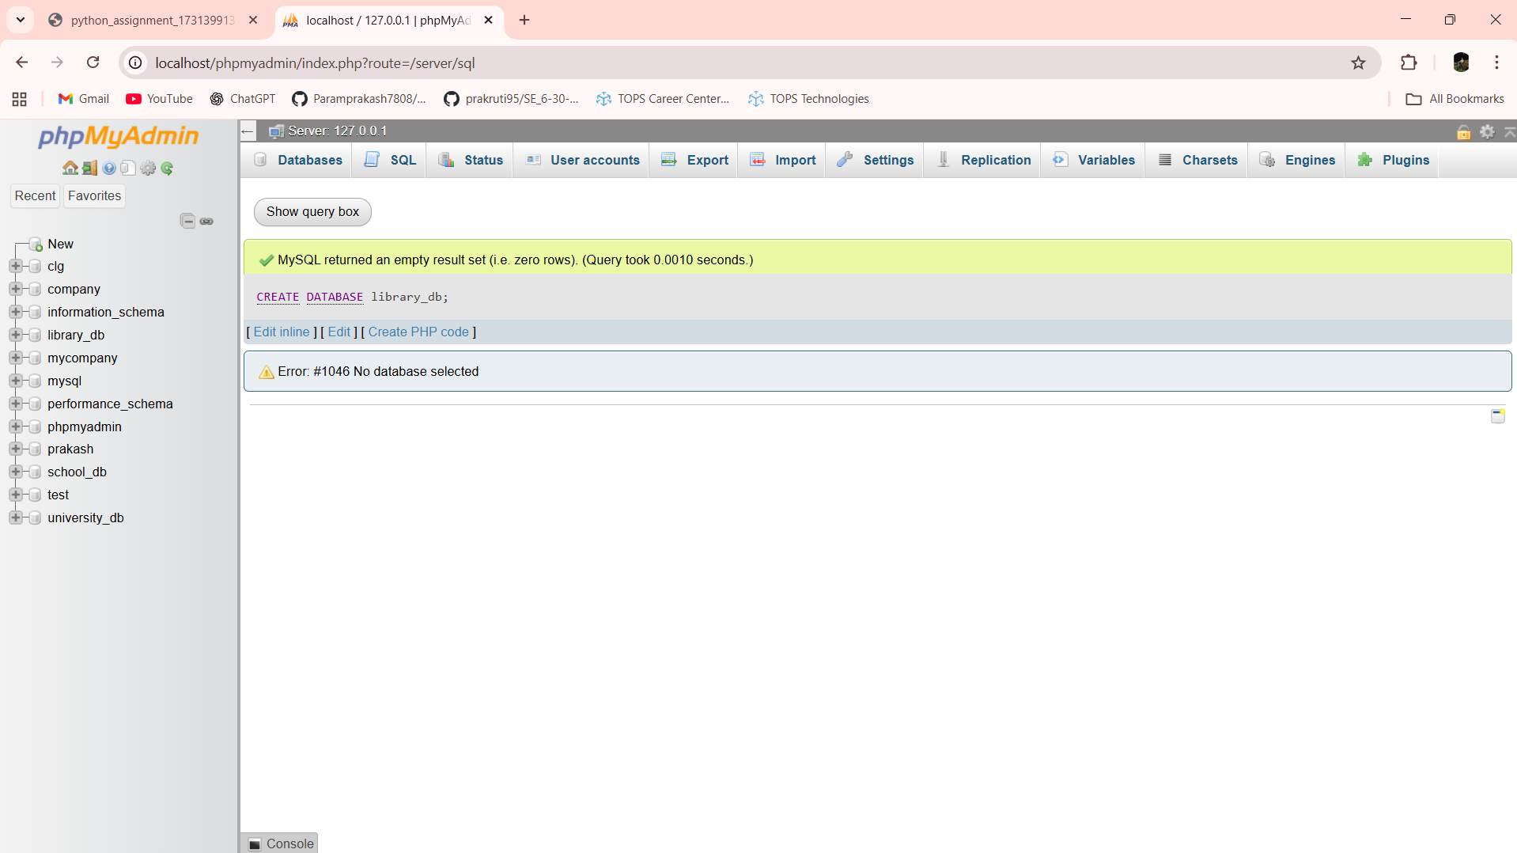

CREATE TABLE books (book_id INT PRIMARY KEY,title VARCHAR(100),author VARCHAR(100),publisher VARCHAR(100),year_of_publication INT,price int);

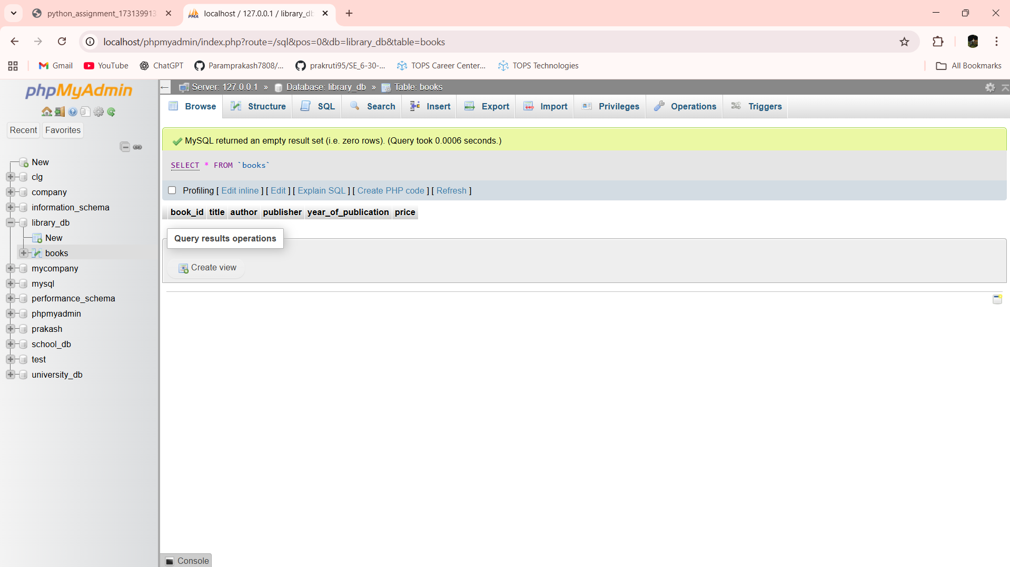

INSERT INTO books VALUES

(1, 'The Alchemist', 'Paulo Coelho', 'HarperCollins', 1988, 399.00),

(2, 'Clean Code', 'Robert C. Martin', 'Prentice Hall', 2008, 799.00),

(3, 'Atomic Habits', 'James Clear', 'Penguin', 2018, 499.00),

(4, 'Think Like a Monk', 'Jay Shetty', 'Simon & Schuster', 2020, 450.00),

(5, 'Rich Dad Poor Dad', 'Robert Kiyosaki', 'Warner Books', 1997, 350.00);

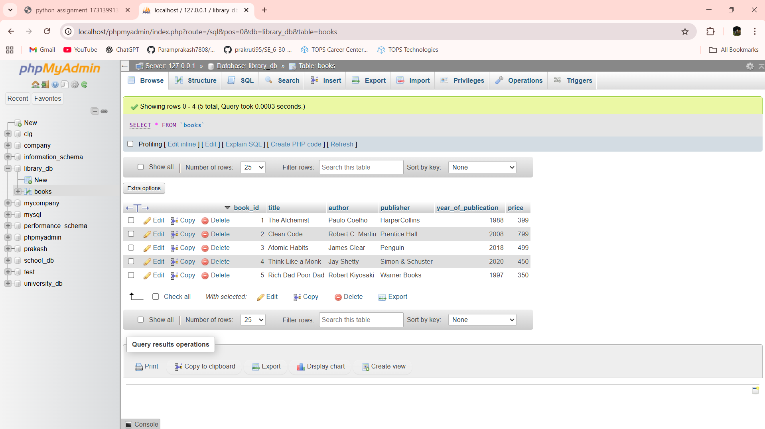

Lab 1.4: Create a table members in library_db with columns: member_id, member_name, date_of_membership, and email. Insert five records into this table.

Ans:- CREATE TABLE members (member_id INT PRIMARY KEY,member_name VARCHAR(100),date_of_membership DATE,email VARCHAR(100))

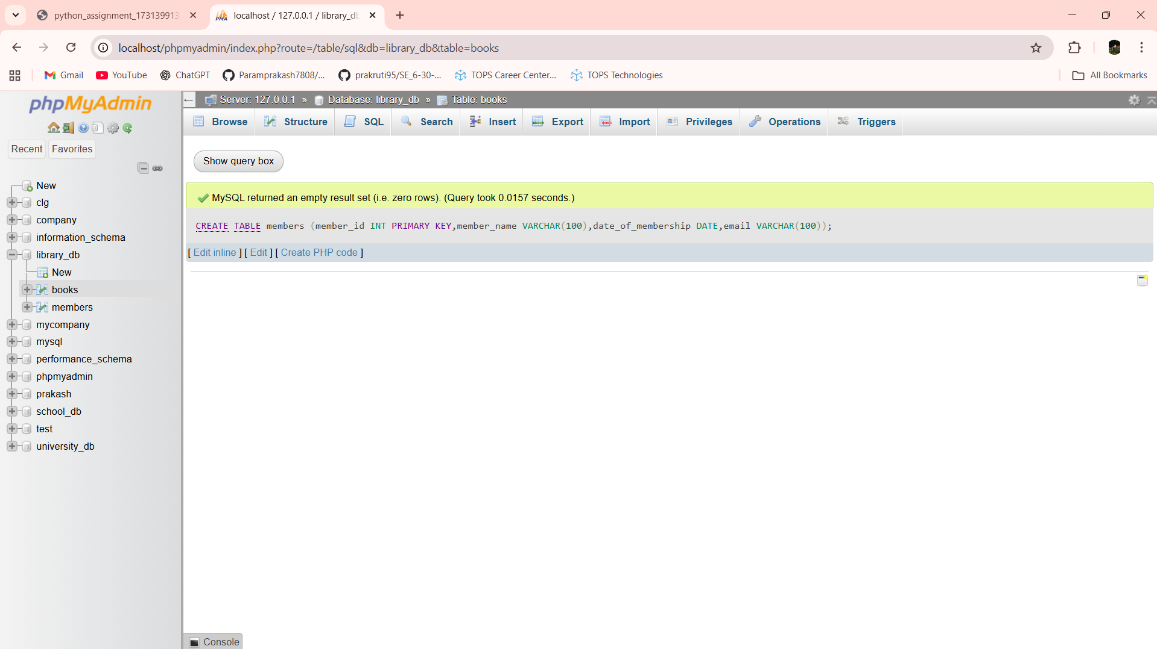

INSERT INTO members VALUES

(1, 'Ajay Makwana', '2023-01-15', 'ajay@gmail.com'),

(2, 'Sahil Makwana', '2023-03-10', 'sahil@gmail.com'),

(3, 'Mayur Makwana', '2023-05-22', 'mayur@gmail.com'),

(4, 'Darshit Makwana', '2023-07-08', 'darshit@gmail.com'),

(5, 'Prakash Makwana', '2023-09-18', 'prakash@gmail.com');

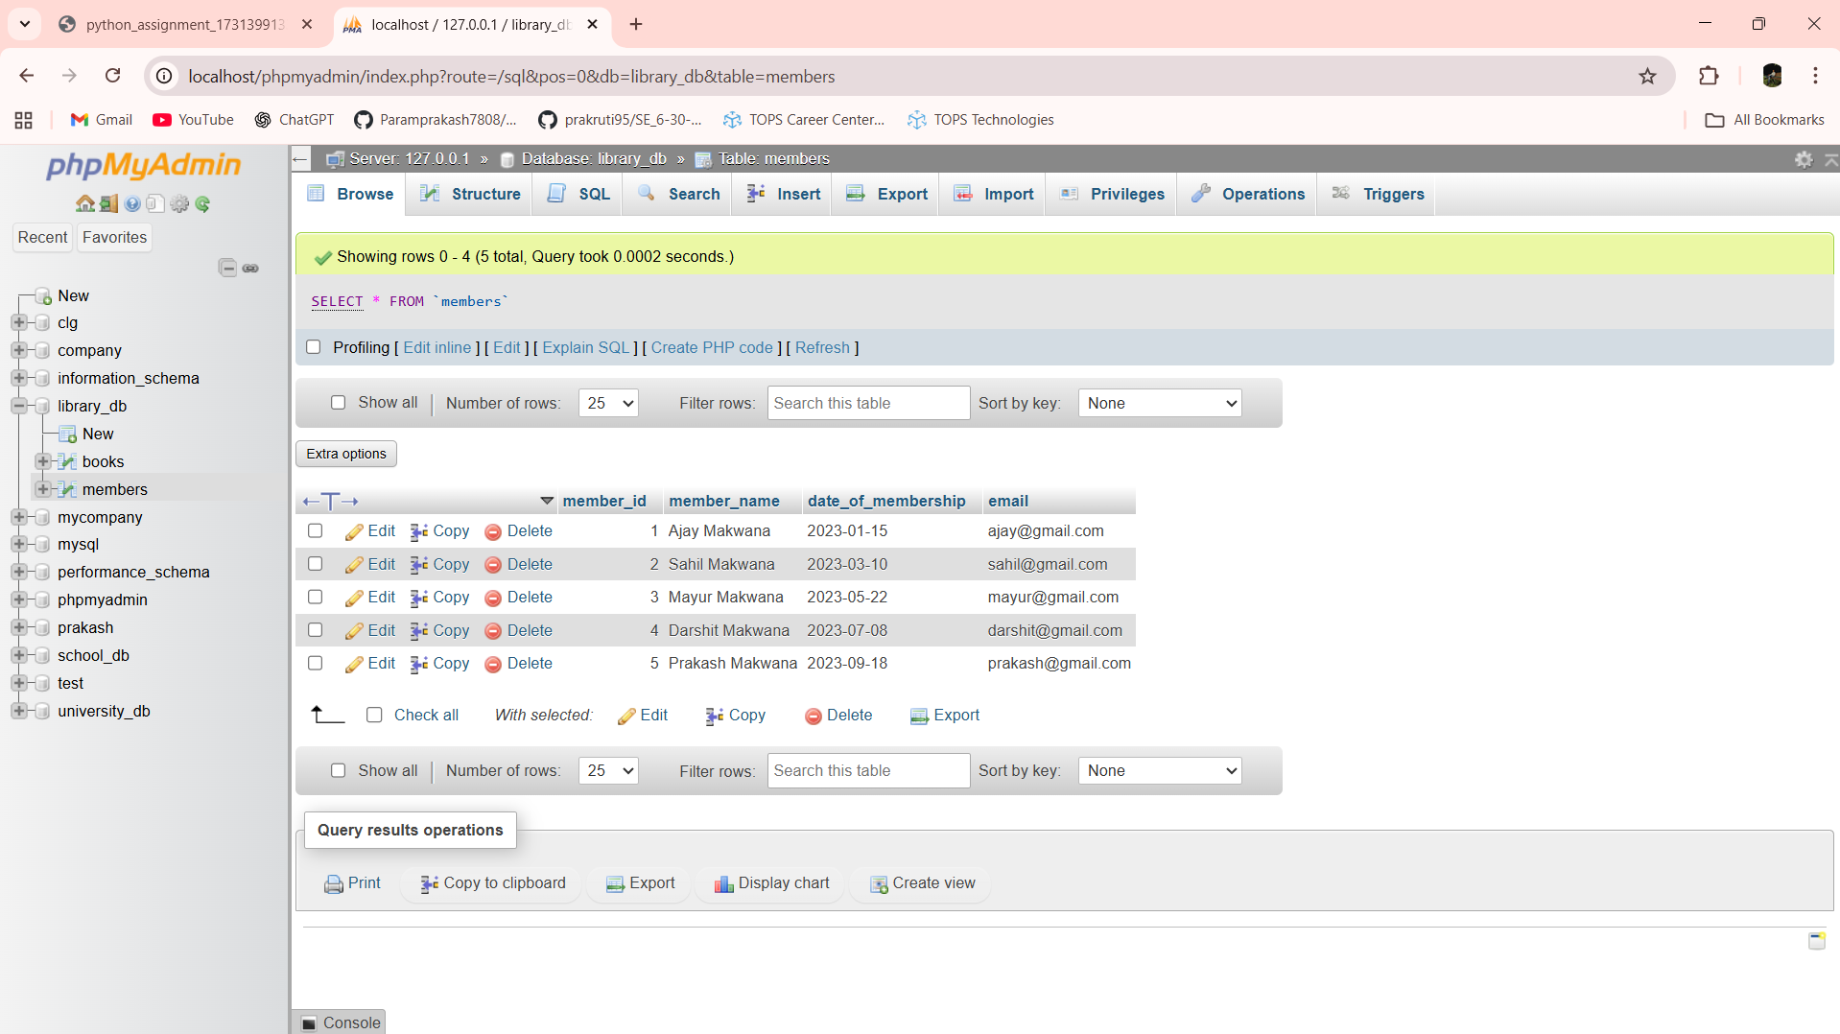

Lab 2.3: Retrieve all members who joined the library before 2022. Use appropriate SQL syntax with WHERE and ORDER BY.

Ans:- SELECT * FROM members WHERE date_of_membership < '2022-01-01' ORDER BY date_of_membership

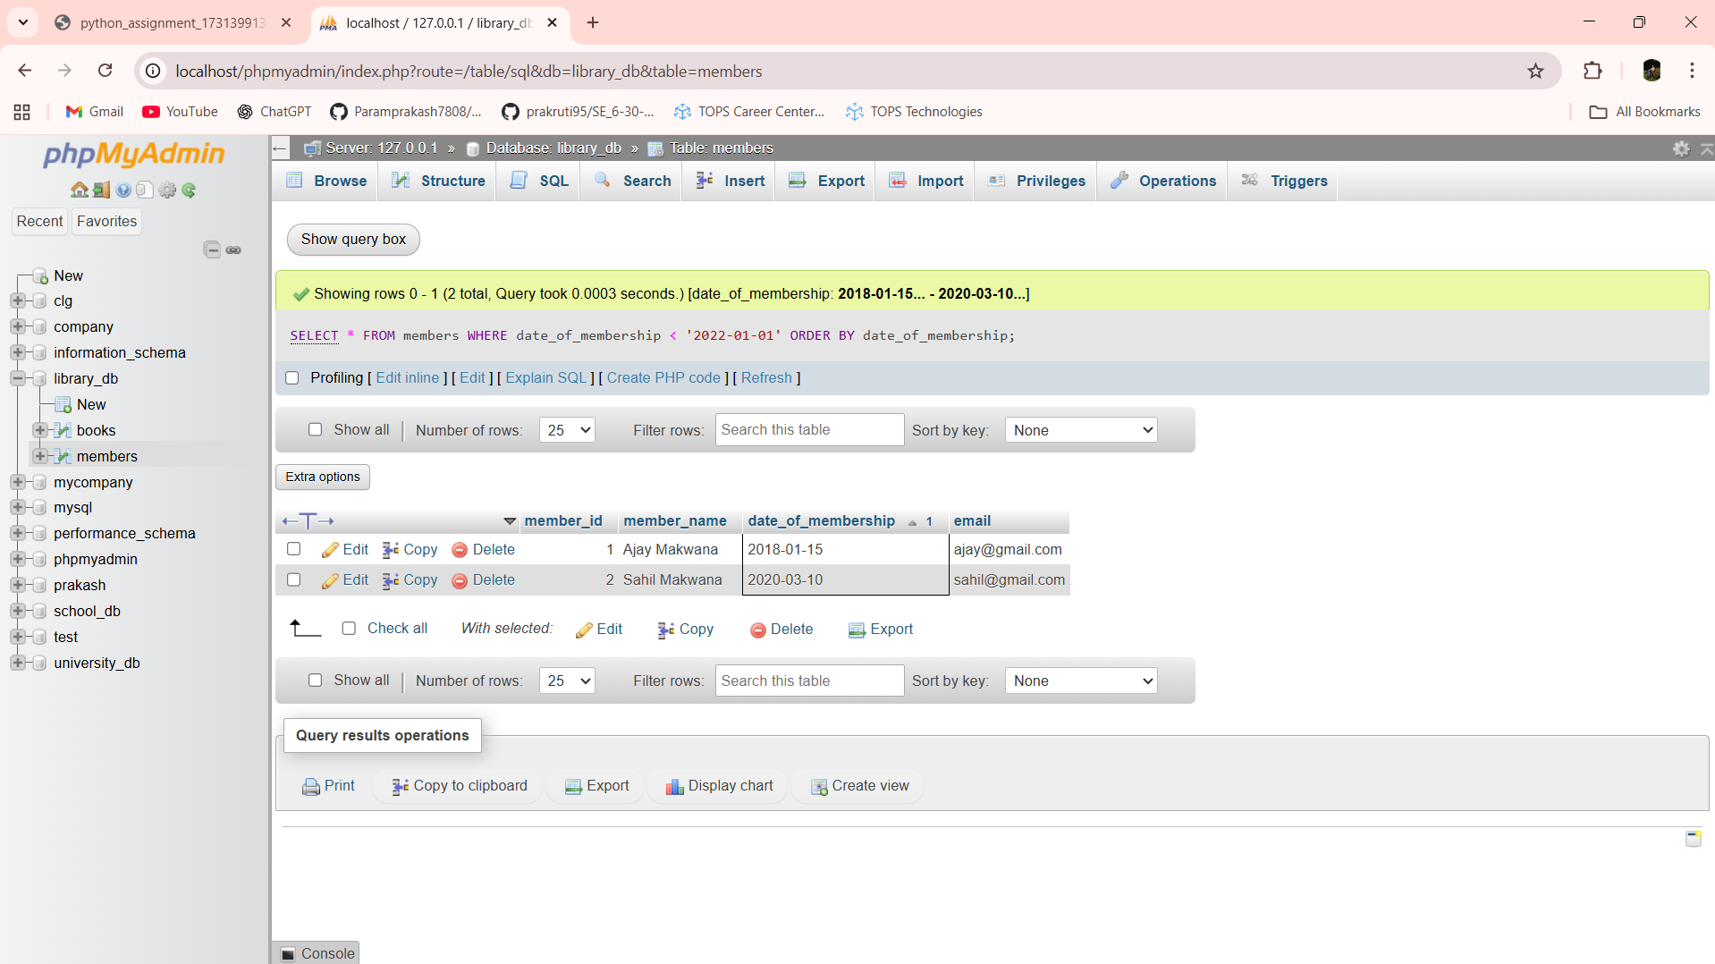

Lab 2.4: Write SQL queries to display the titles of books published by a specific author. Sort the results by year_of_publication in descending order.

Ans:- SELECT title FROM books WHERE author = 'Robert Kiyosaki' ORDER BY year_of_publication DESC

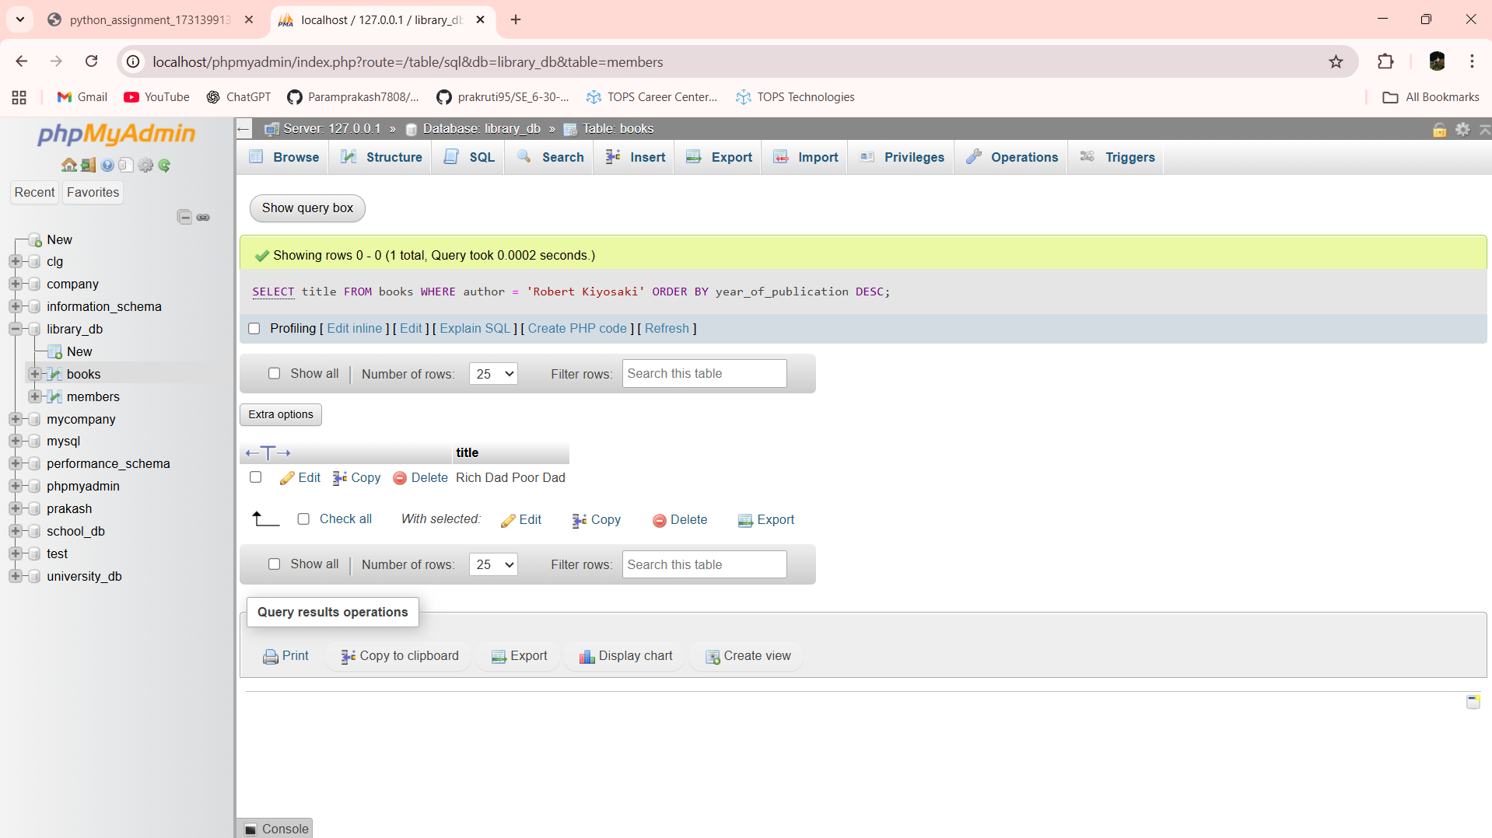

Lab 3.3: Add a CHECK constraint to ensure that the price of books in the books table is greater than 0.

Ans:- ALTER TABLE books ADD CONSTRAINT chk_price CHECK (price > 0)

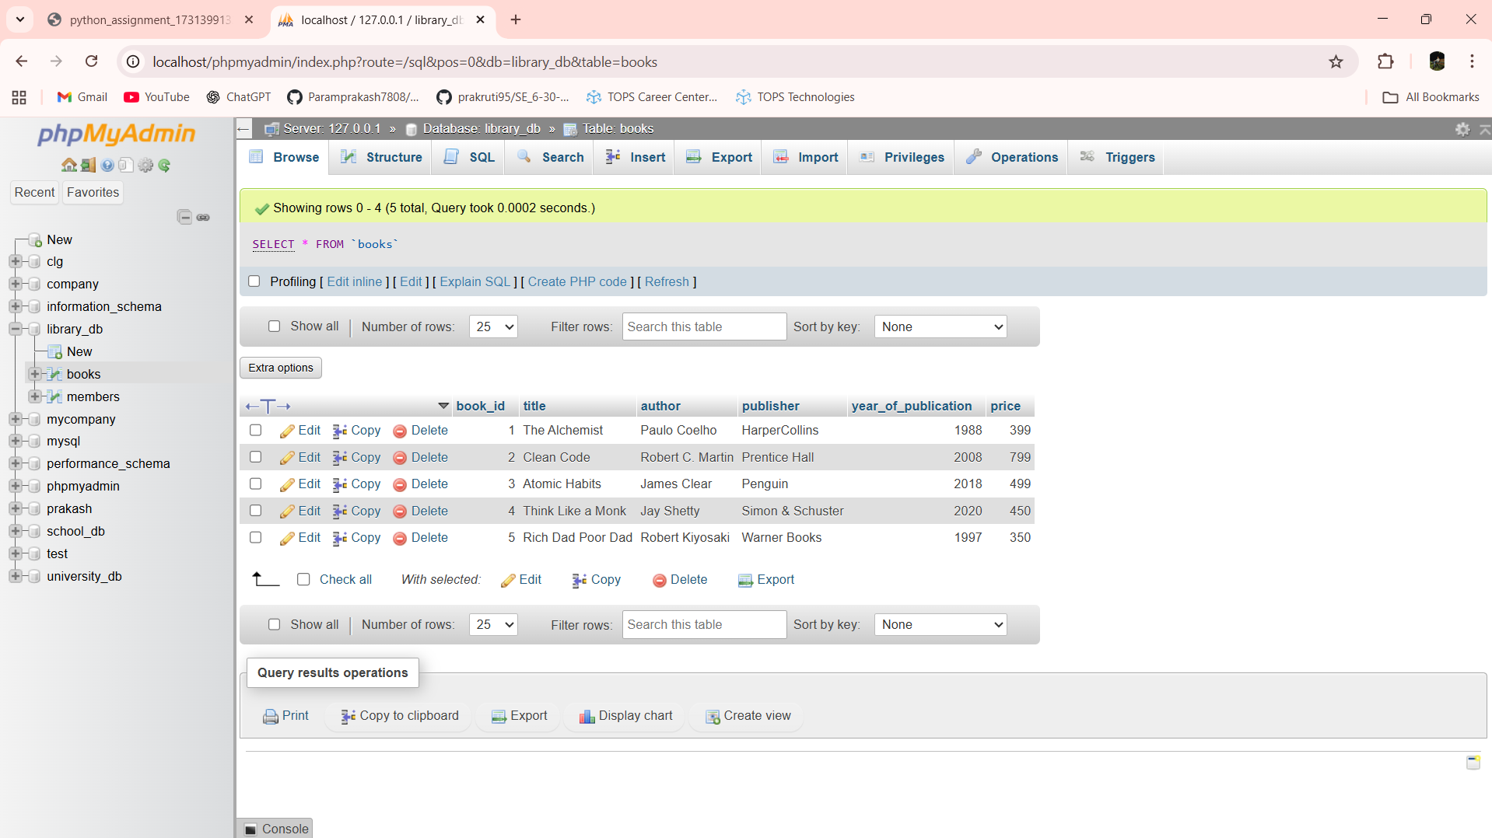

Lab 3.4: Modify the members table to add a UNIQUE constraint on the email column, ensuring that each member has a unique email address.

Ans:- ALTER TABLE members ADD CONSTRAINT uq_email UNIQUE (email)

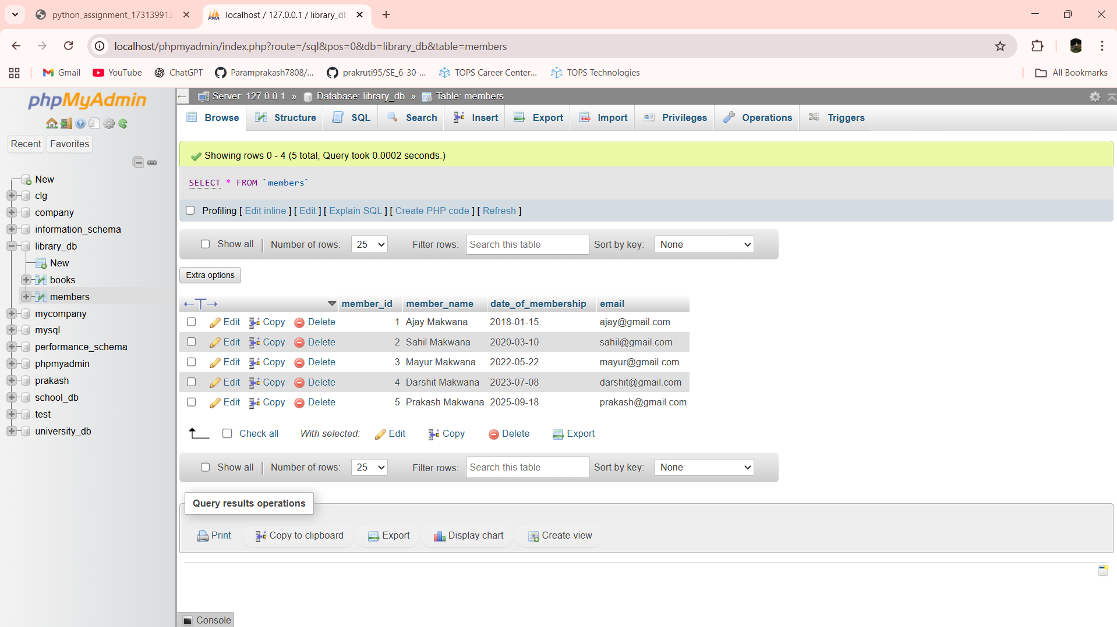

Lab 4.3: Create a table authors with the following columns: author_id, first_name, last_name, and country. Set author_id as the primary key.

Ans:- CREATE TABLE authors (author_id INT PRIMARY KEY,first_name VARCHAR(50),last_name VARCHAR(50),country VARCHAR(50))

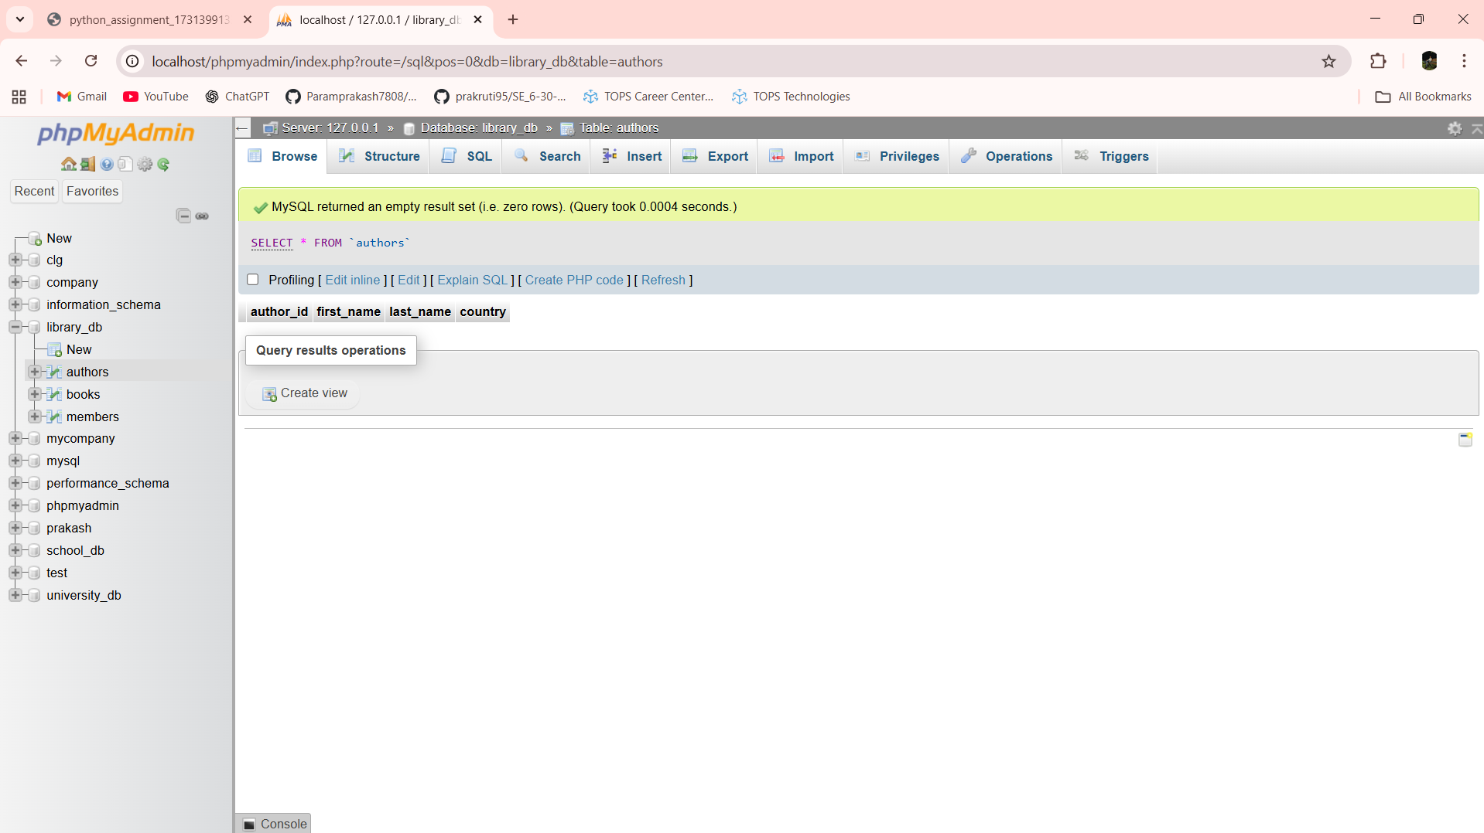

Lab 4.4: Create a table publishers with columns: publisher_id, publisher_name, contact_number, and address. Set publisher_id as the primary key and contact_number as unique.

Ans:- CREATE TABLE publishers (publisher_id INT PRIMARY KEY,publisher_name VARCHAR(100),contact_number VARCHAR(15) UNIQUE,address VARCHAR(150))

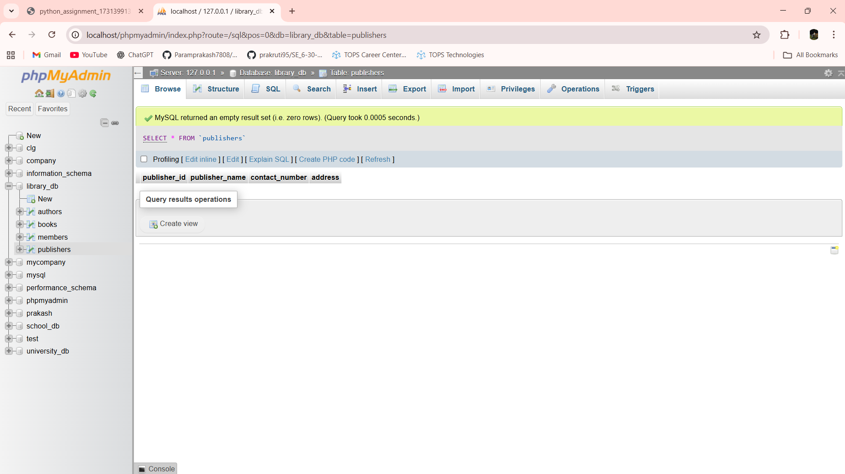

Lab 5.3: Add a new column genre to the books table. Update the genre for all existing records.

Ans:- ALTER TABLE books ADD genre VARCHAR(50)

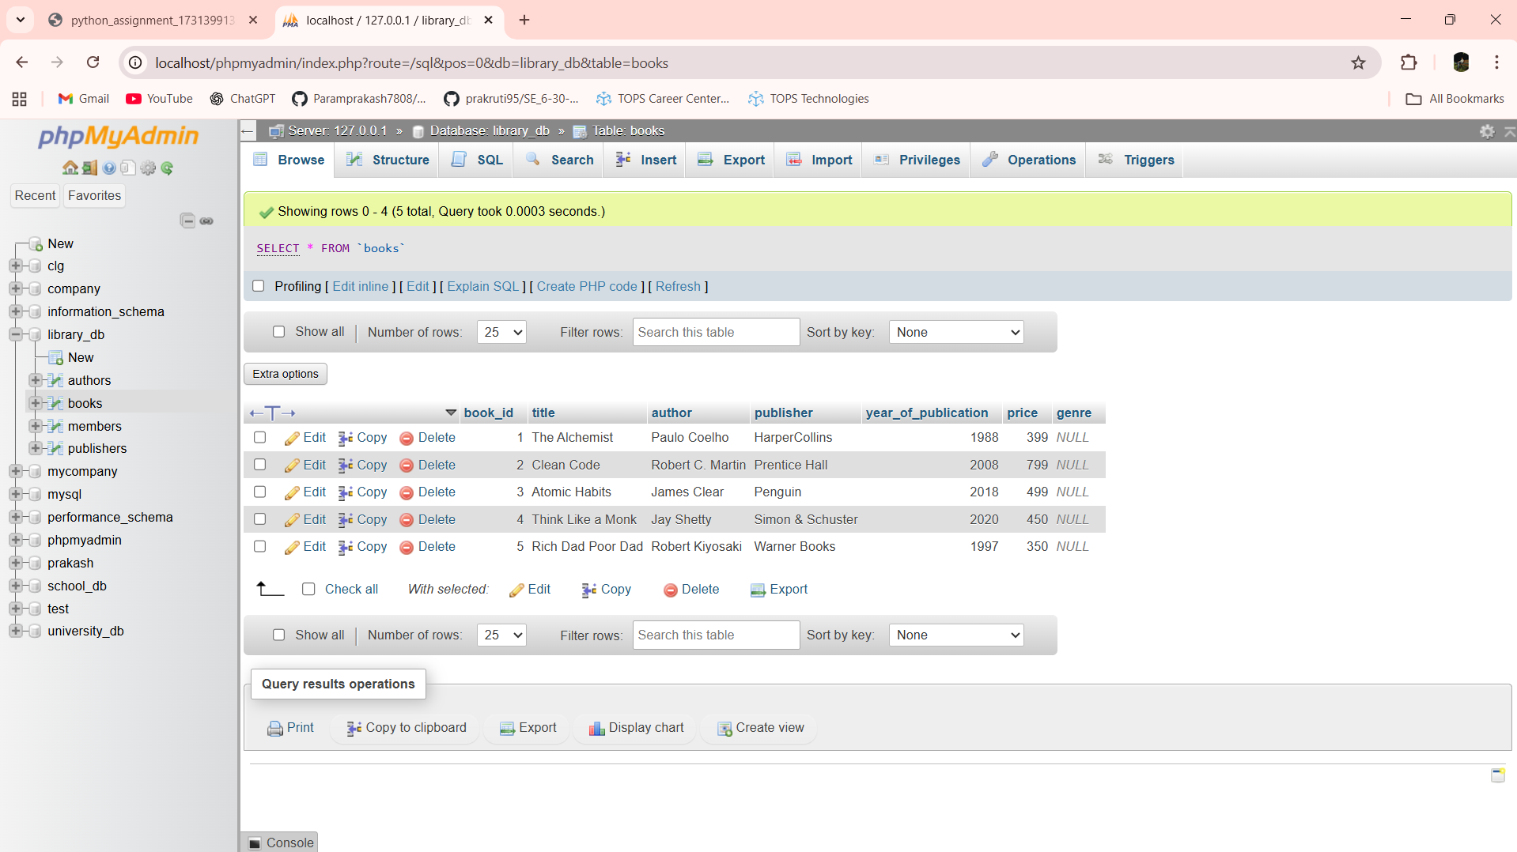

UPDATE books SET genre = 'Fiction'

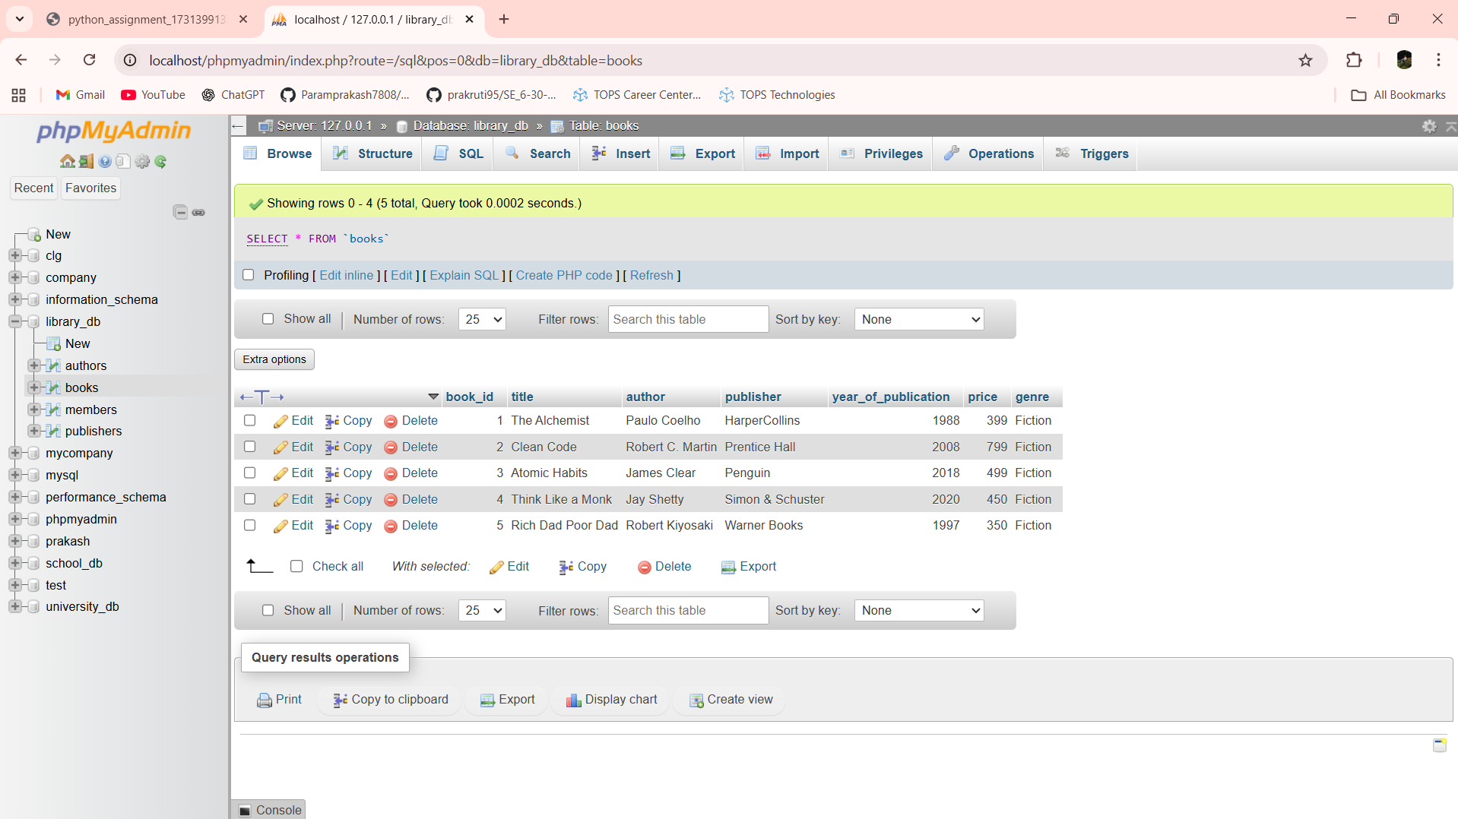

Lab 5.4: Modify the members table to increase the length of the email column to 100 characters.

Ans:- ALTER TABLE members MODIFY email VARCHAR(100)

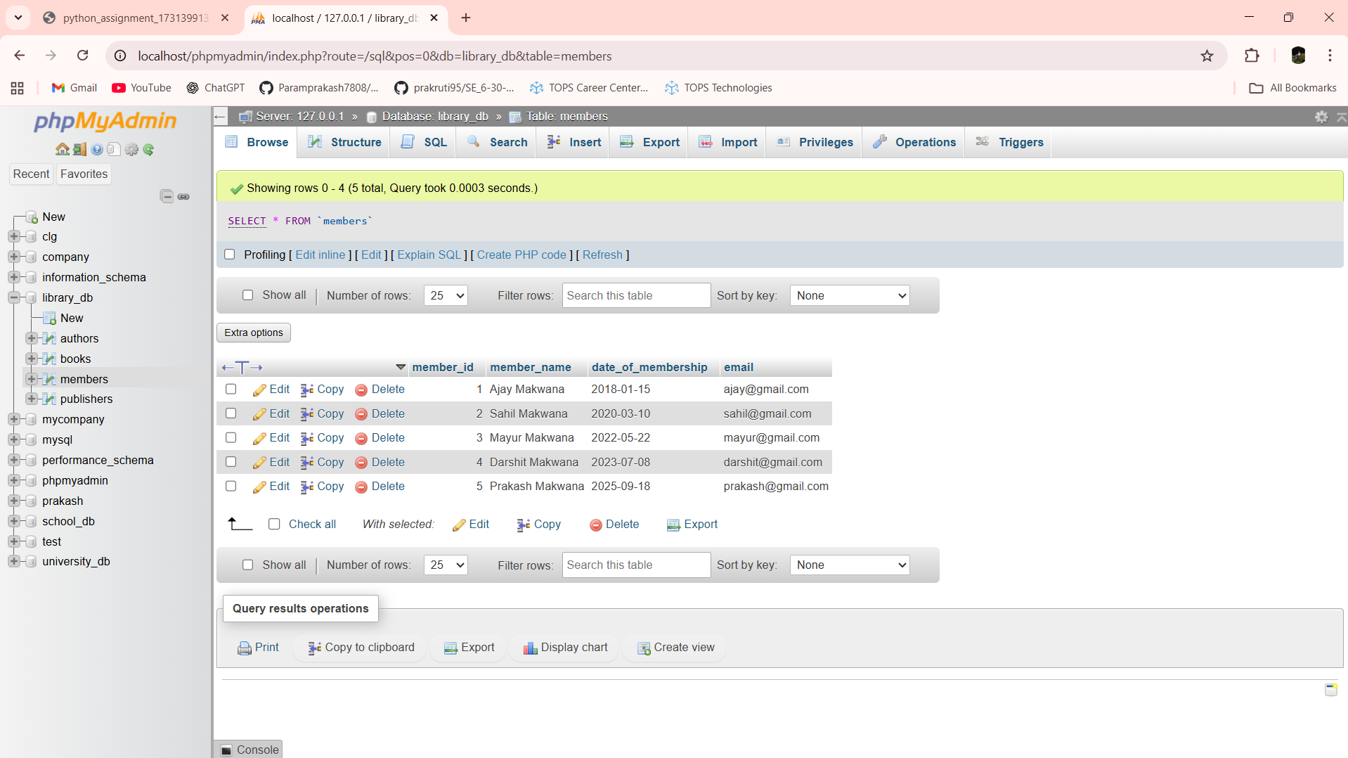

Lab 6.3: Drop the publishers table from the database after verifying its structure.

Ans:-

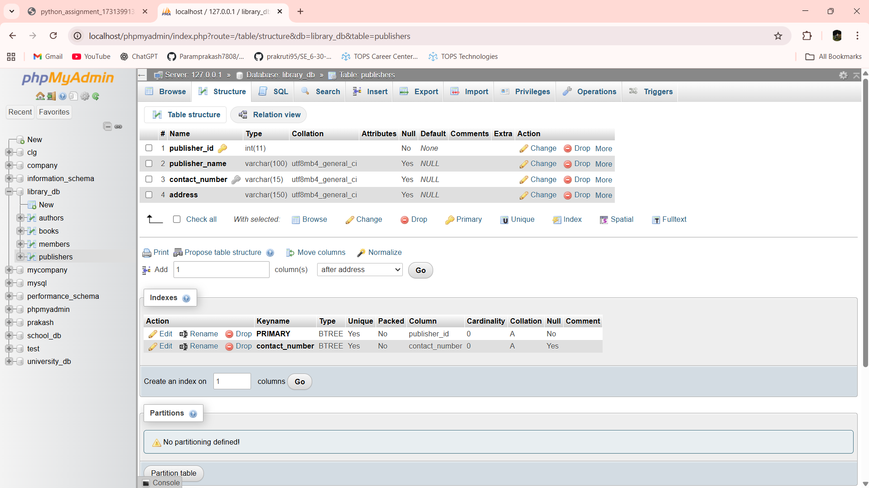

DROP TABLE publishers

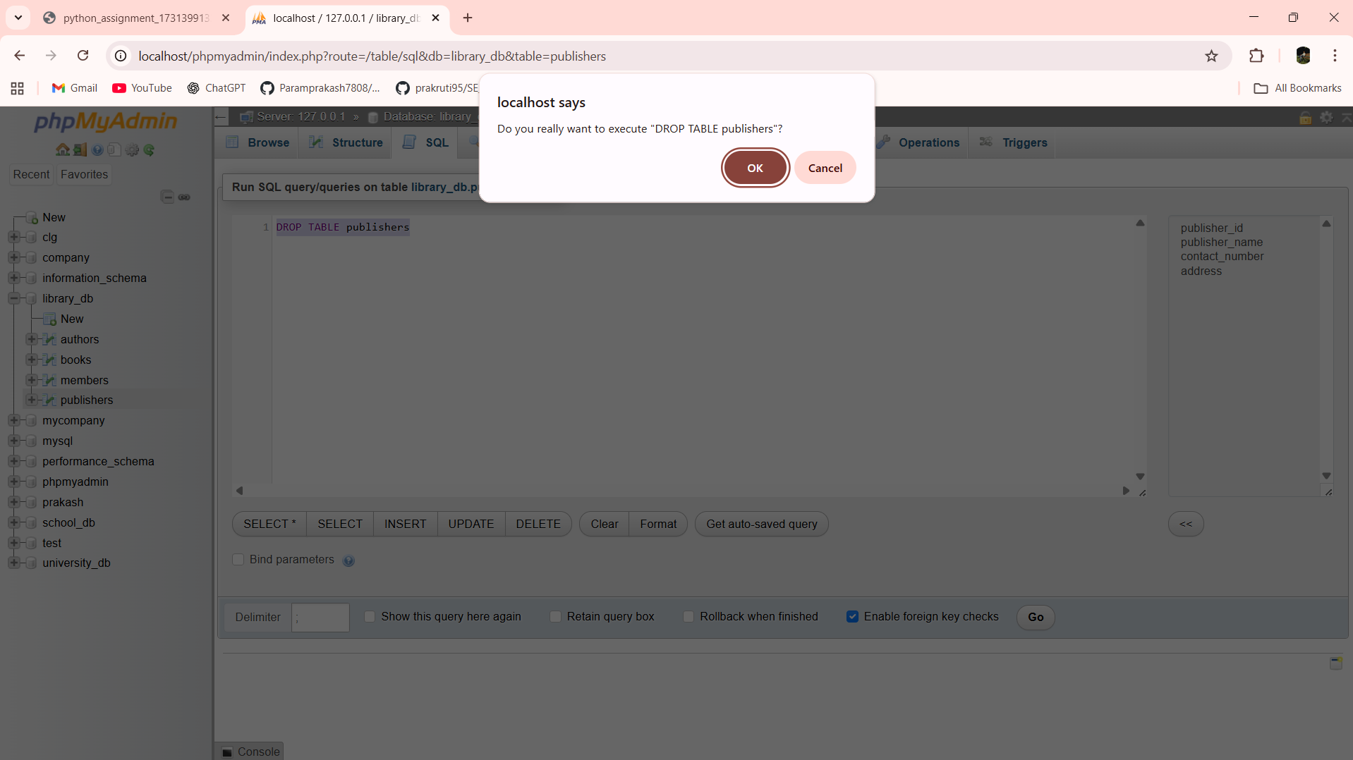

Lab 6.4: Create a backup of the members table and then drop the original members table.

Ans:- CREATE TABLE members_backup AS SELECT * FROM members

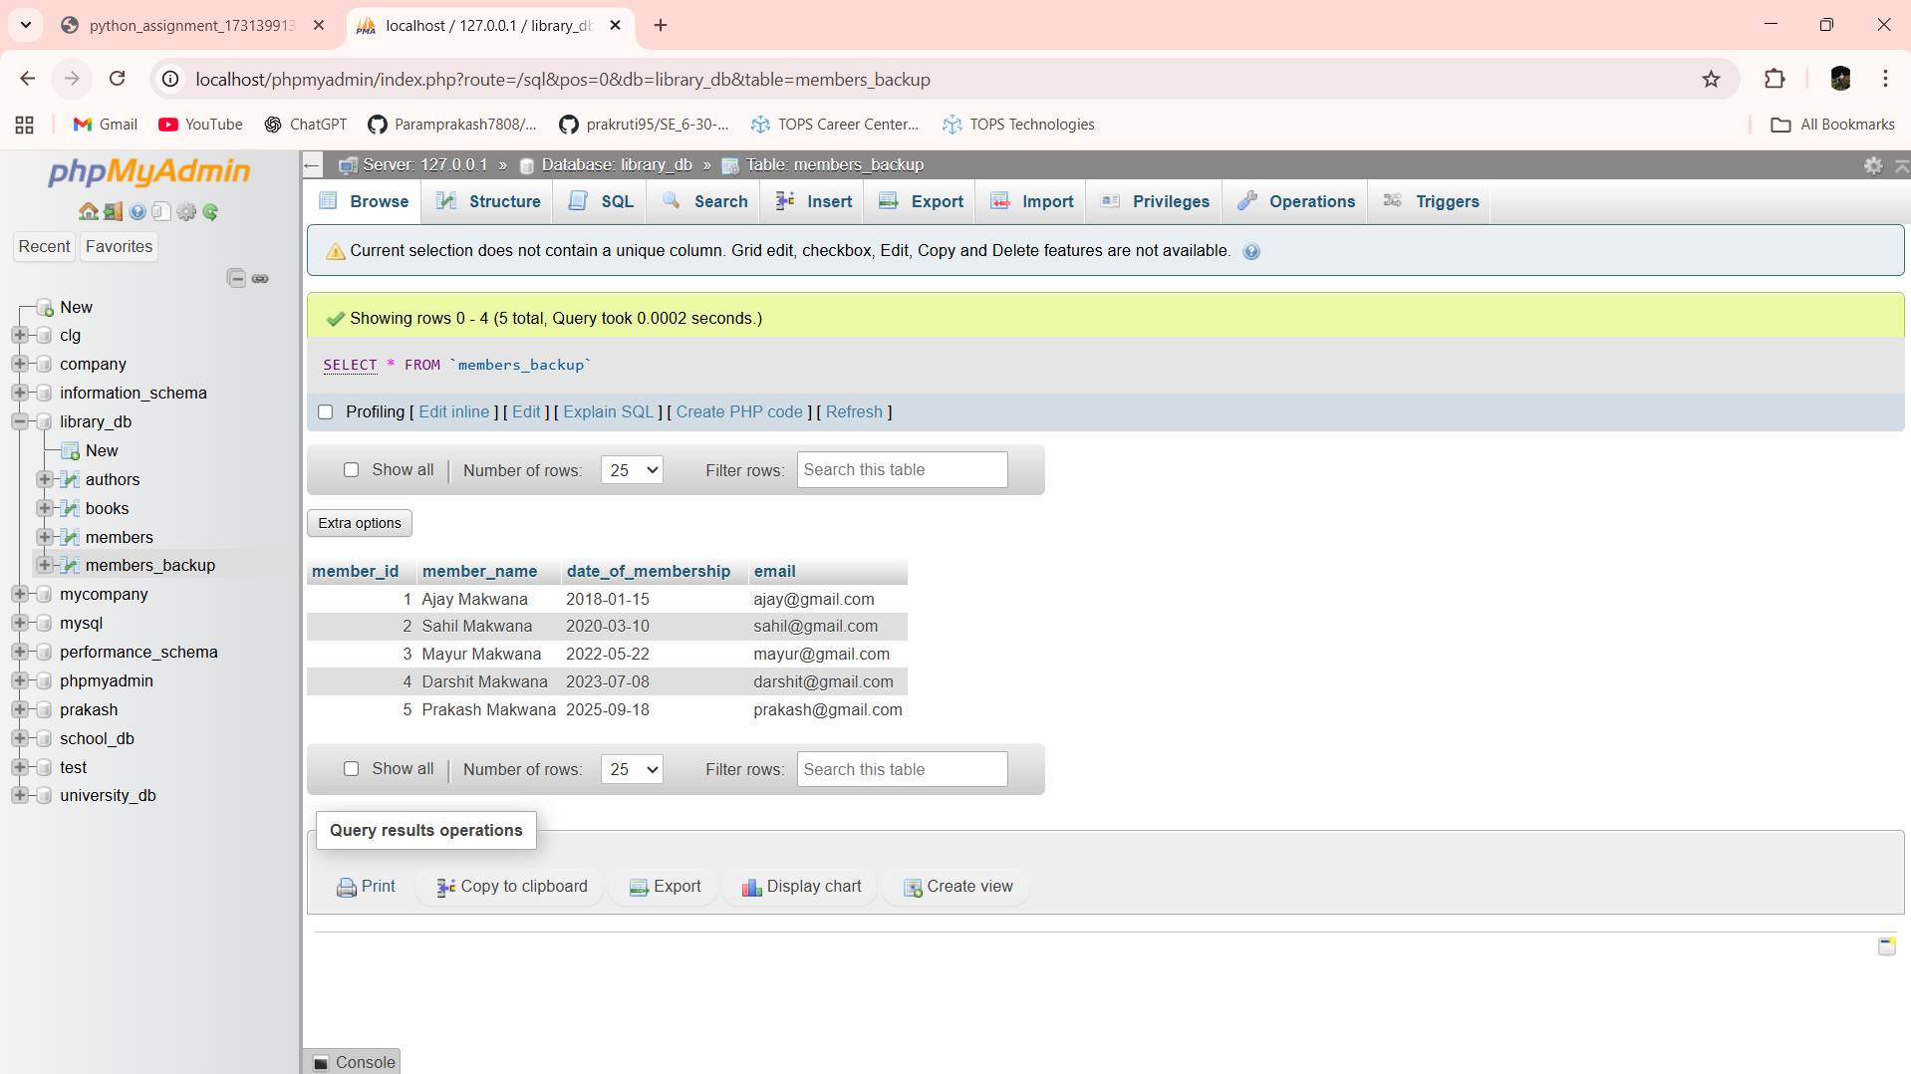

DROP TABLE members

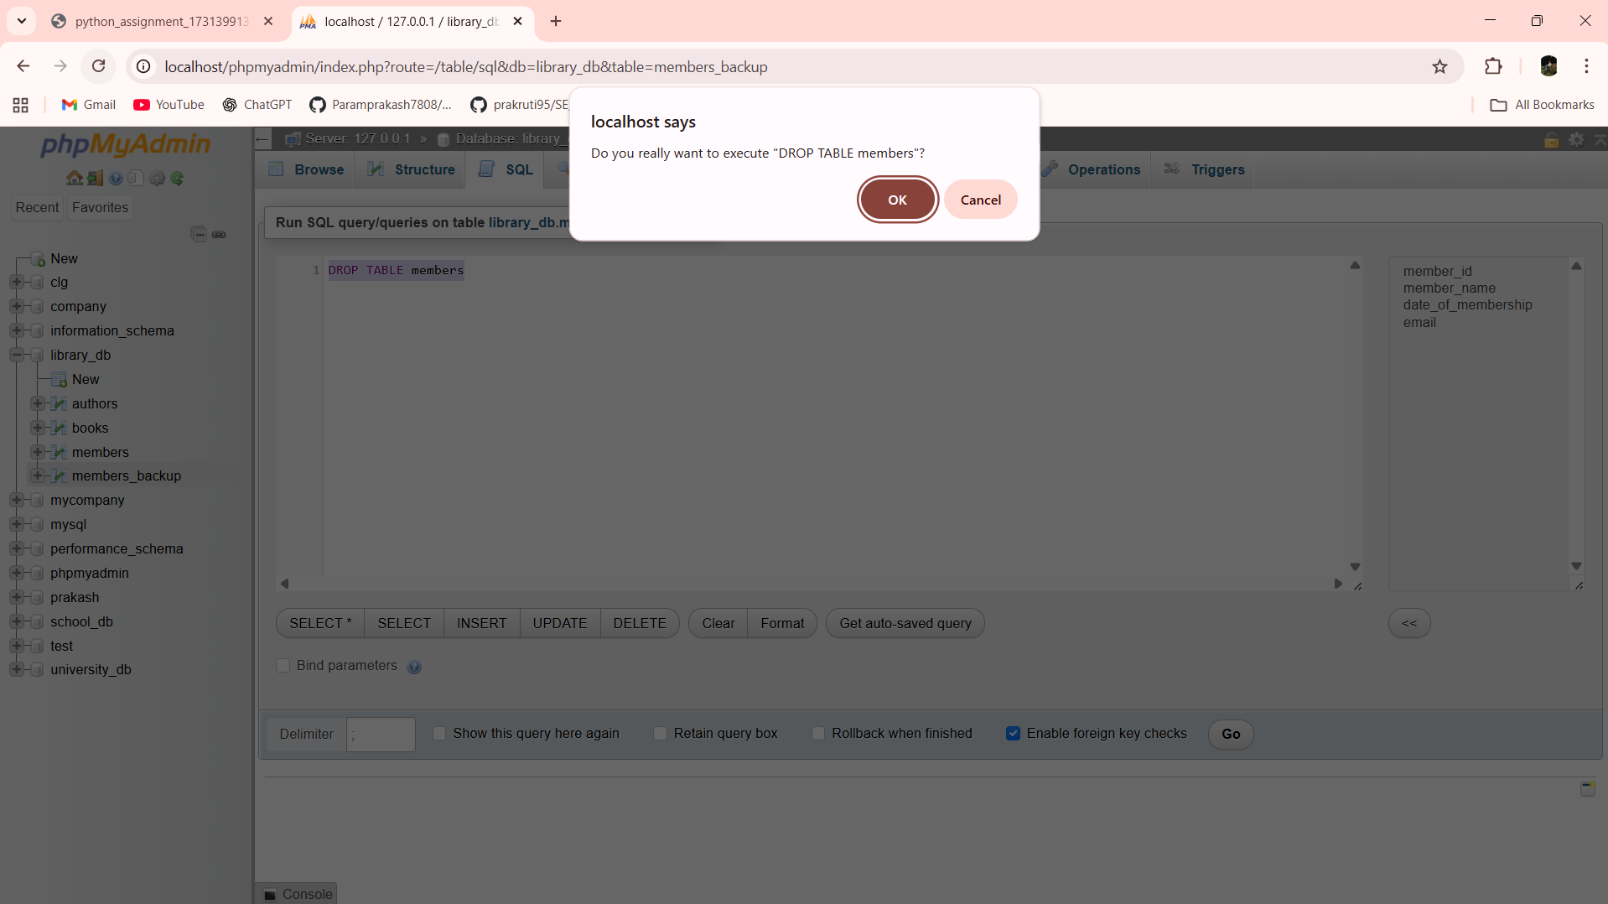

Lab 7.4: Insert three new authors into the authors table, then update the last name of one of the authors.

Ans:- INSERT INTO authors VALUES

(1, 'George', 'Orwell', 'UK'),

(2, 'Jane', 'Austen', 'UK'),

(3, 'Mark', 'Twain', 'USA')

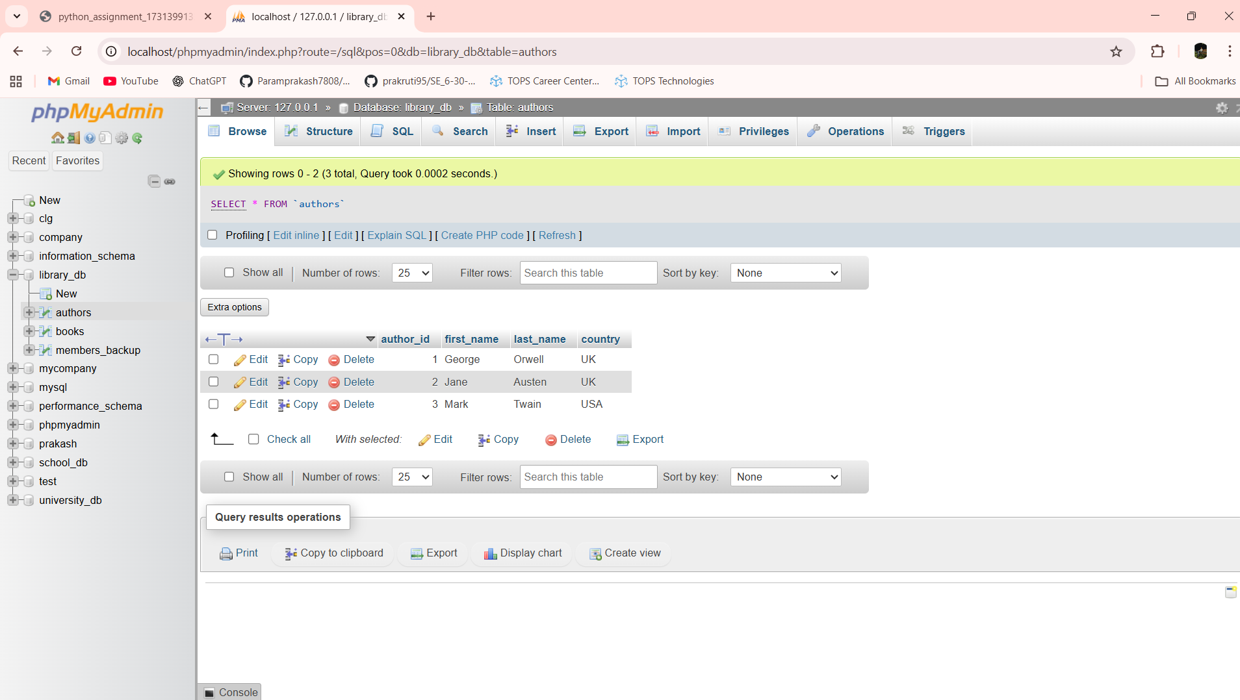

UPDATE authors SET last_name = 'Austin' WHERE author_id = 2

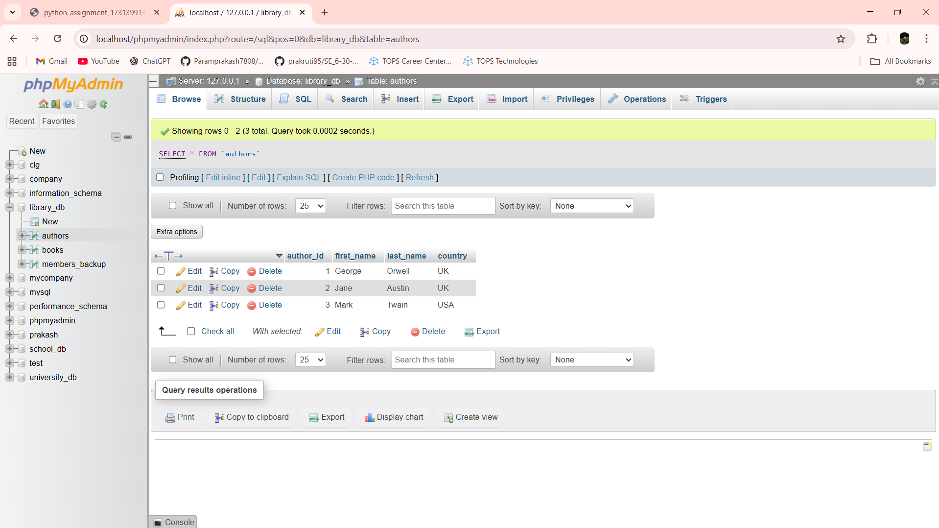

Lab 7.5: Delete a book from the books table where the price is higher than $100.

Ans:- 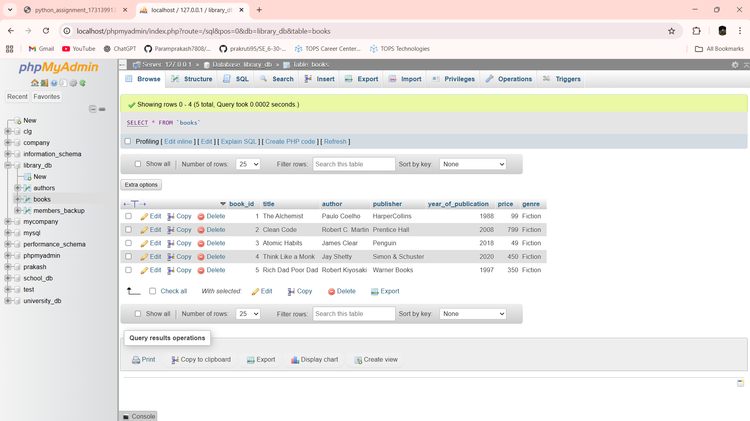

DELETE FROM books WHERE price > 100

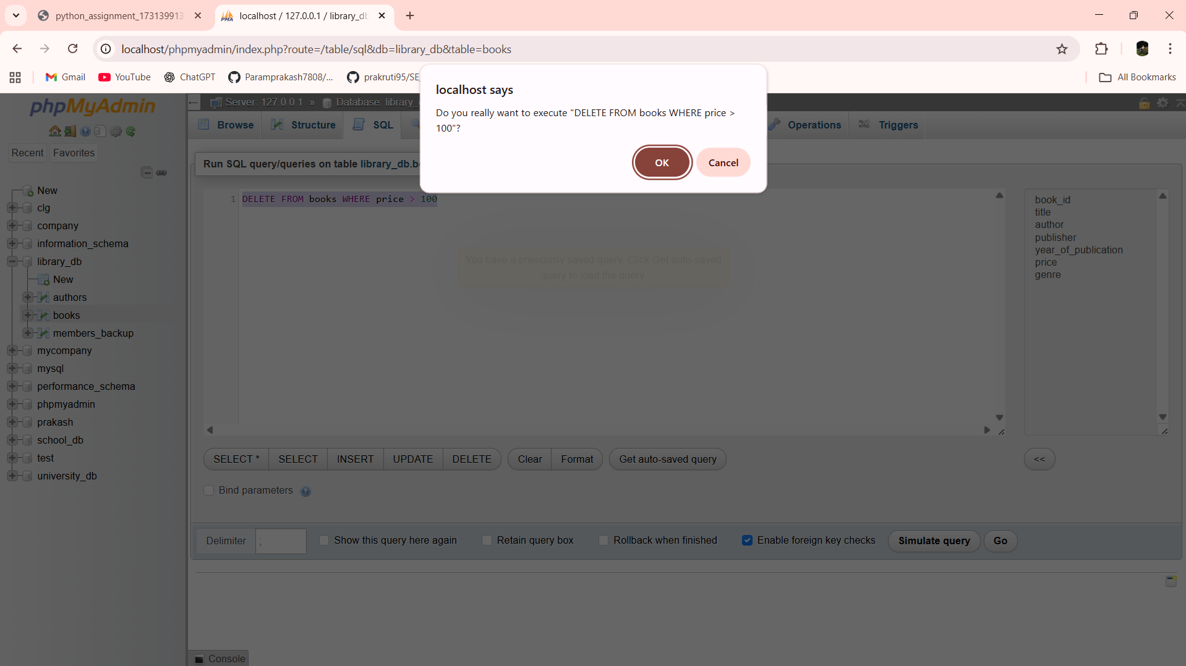

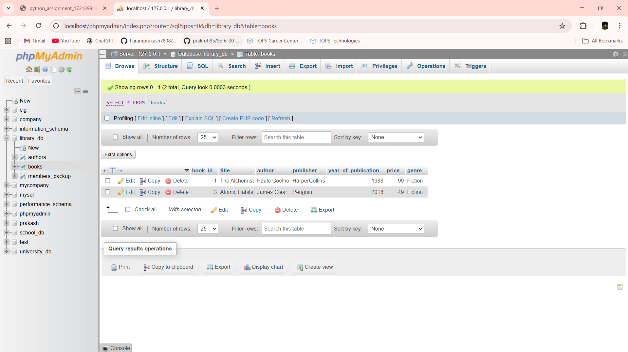

Lab 8.3: Update the year_of_publication of a book with a specific book_id.

Ans:- 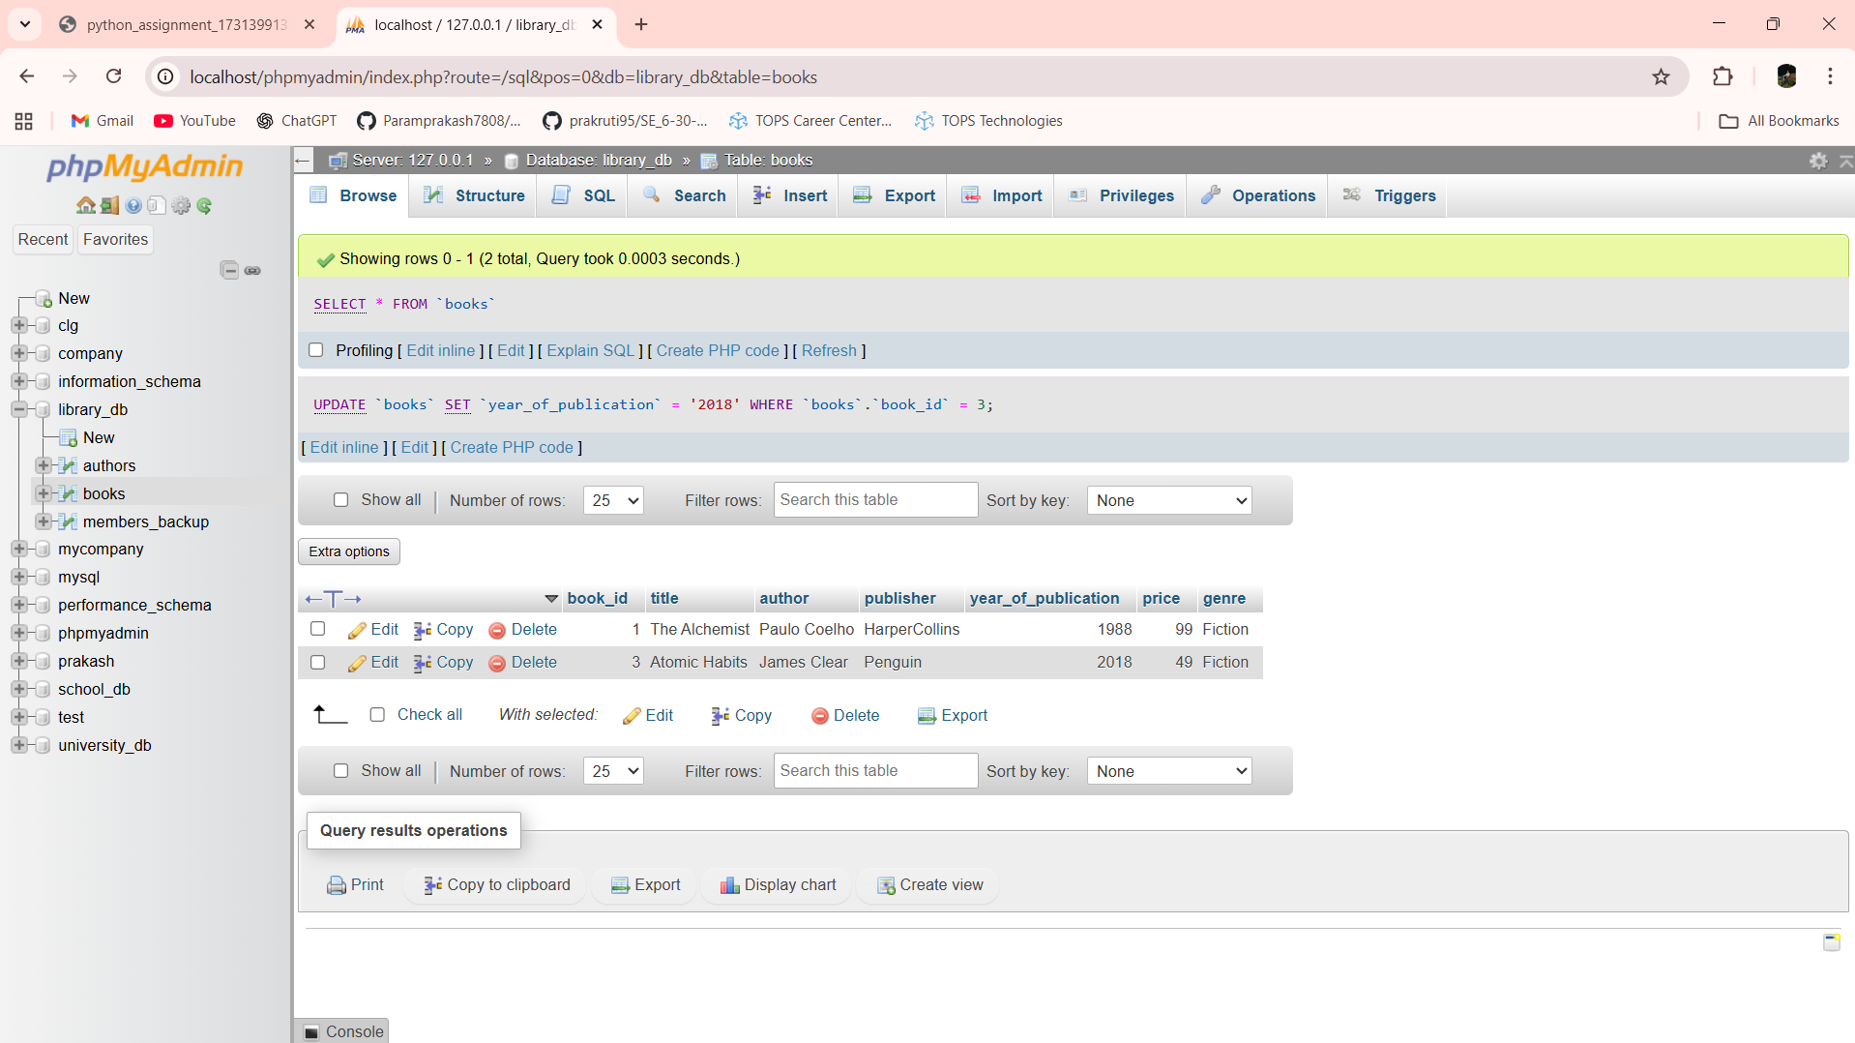

UPDATE books SET year_of_publication = 2021 WHERE book_id = 3

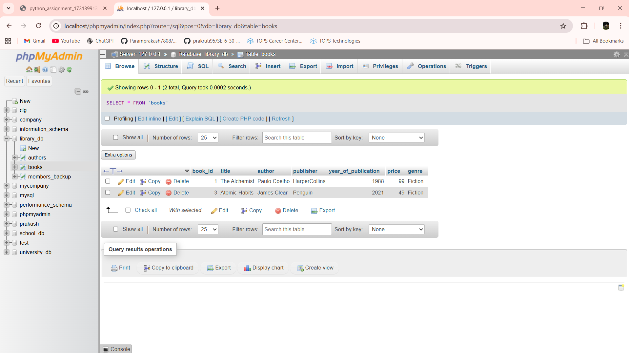

Lab 8.4: Increase the price of all books published before 2015 by 10%.

Ans:- 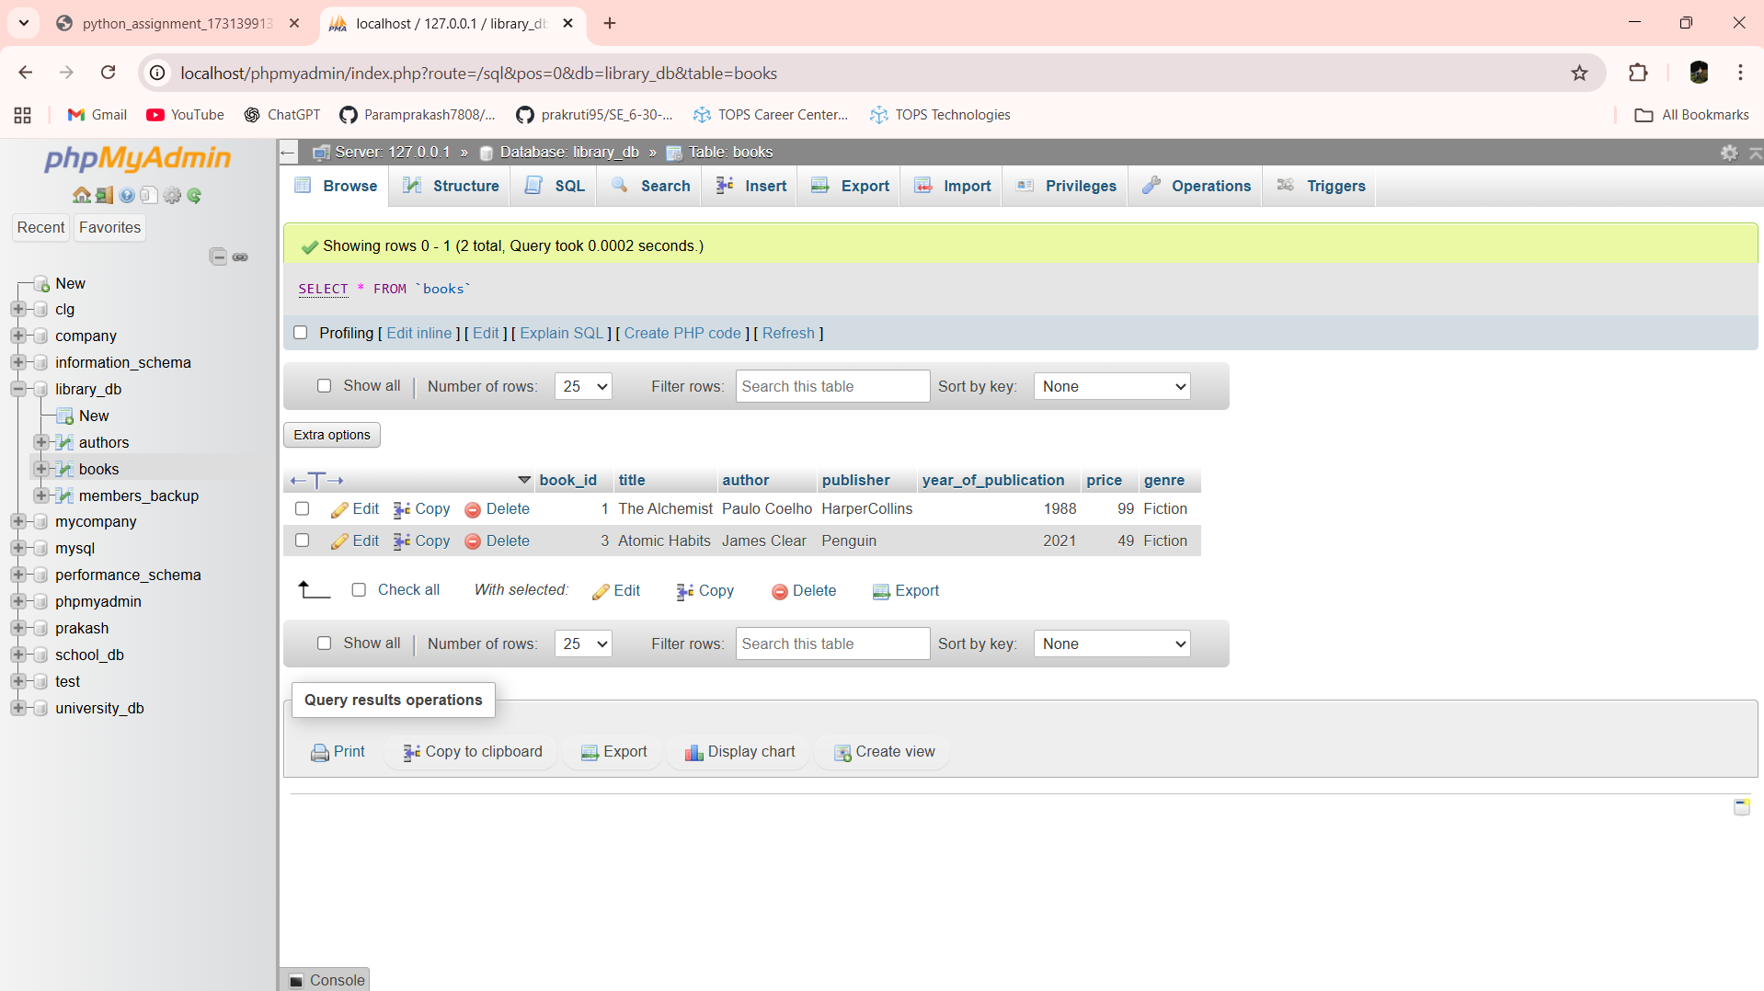

UPDATE books SET price = price + (price * 0.10) WHERE year_of_publication < 2015

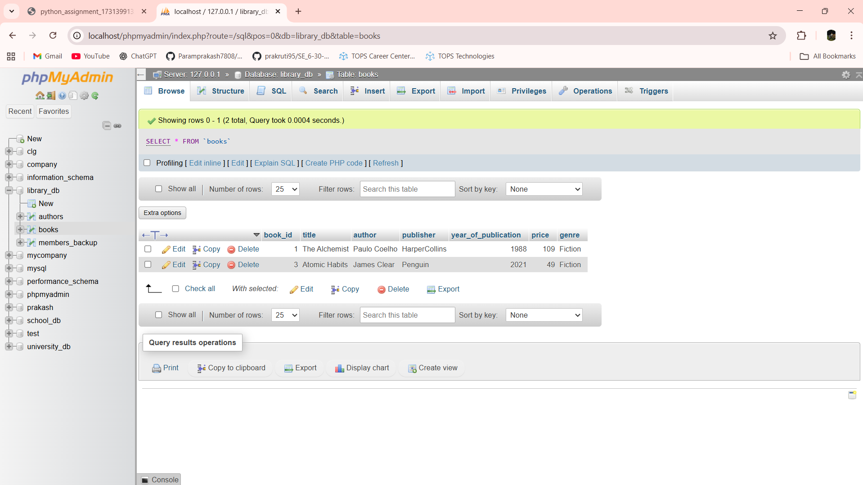

Lab 9.3: Remove all members who joined before 2020 from the members table.

Ans:- 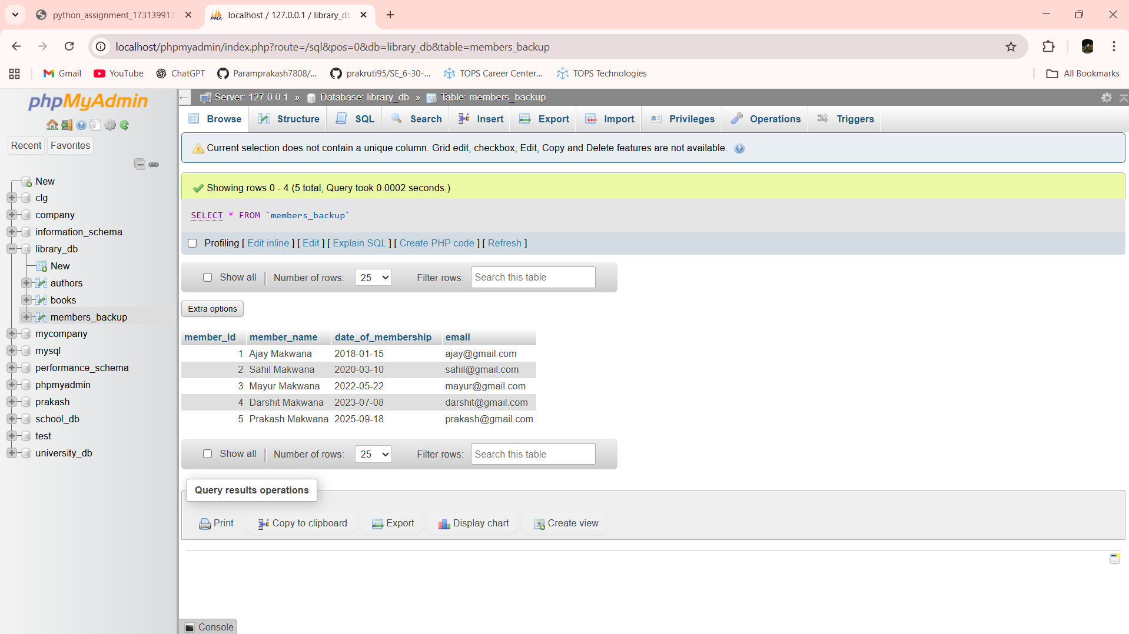

DELETE FROM members_backup WHERE date_of_membership < '2020-01-01'

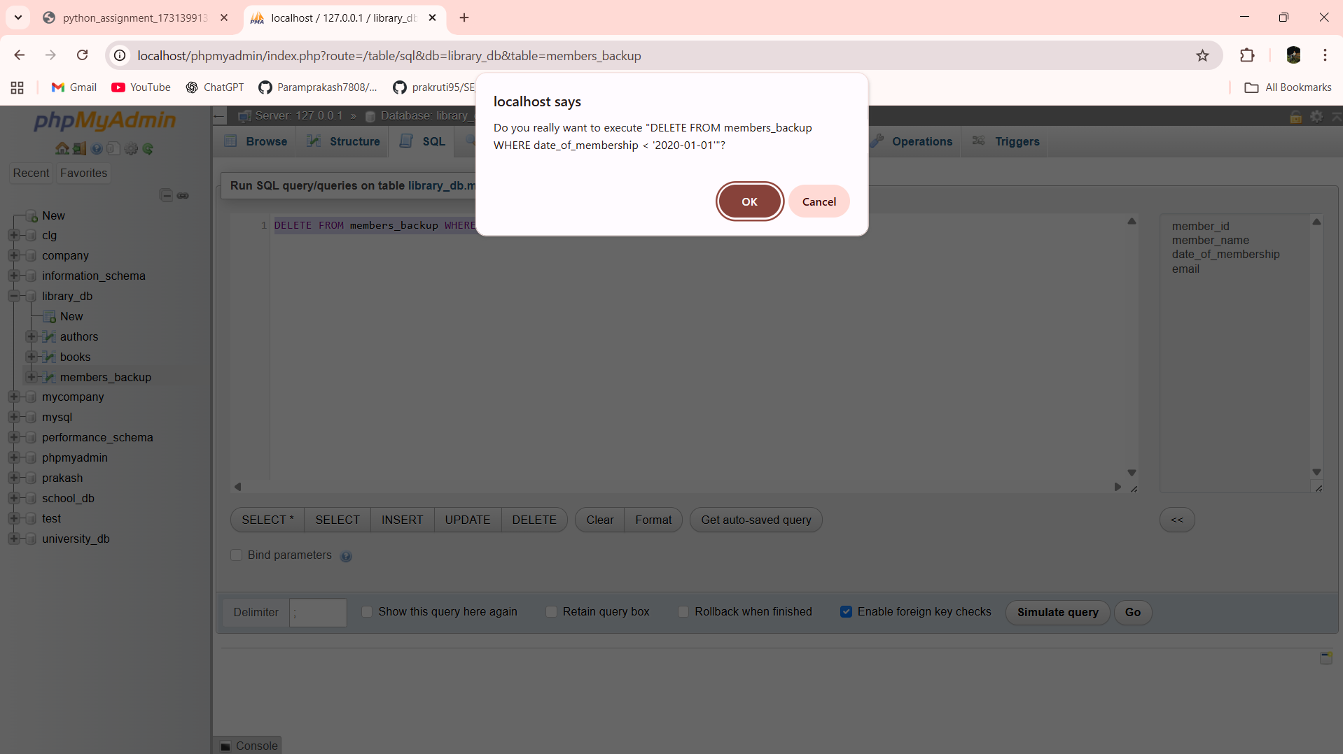

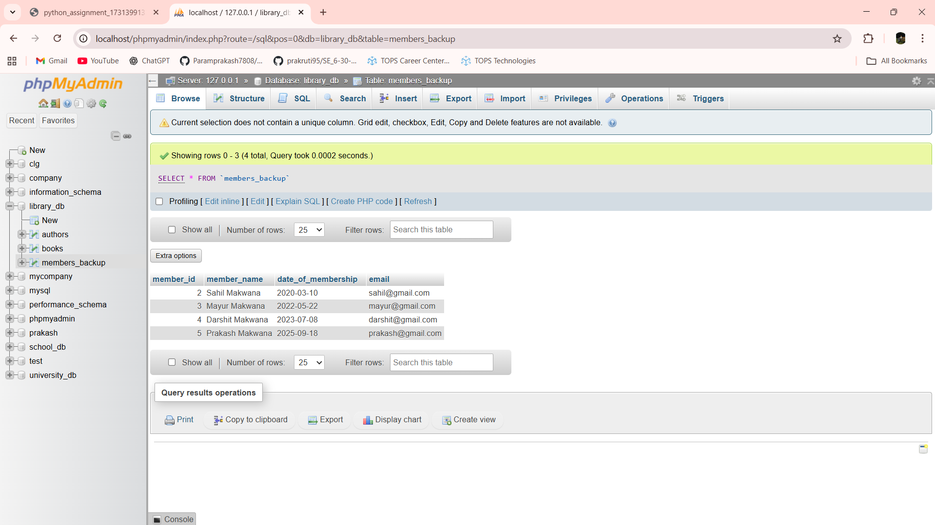

Lab 9.4: Delete all books that have a NULL value in the author column.

Ans:-

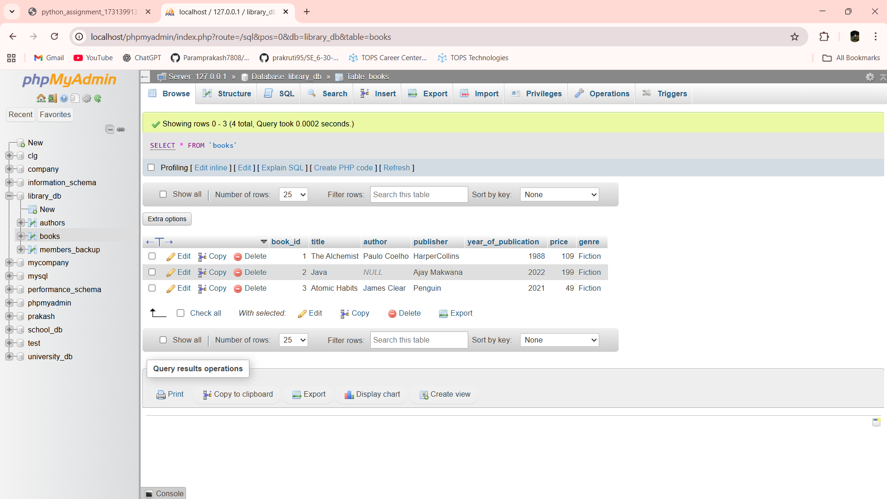

DELETE FROM books WHERE author IS NULL

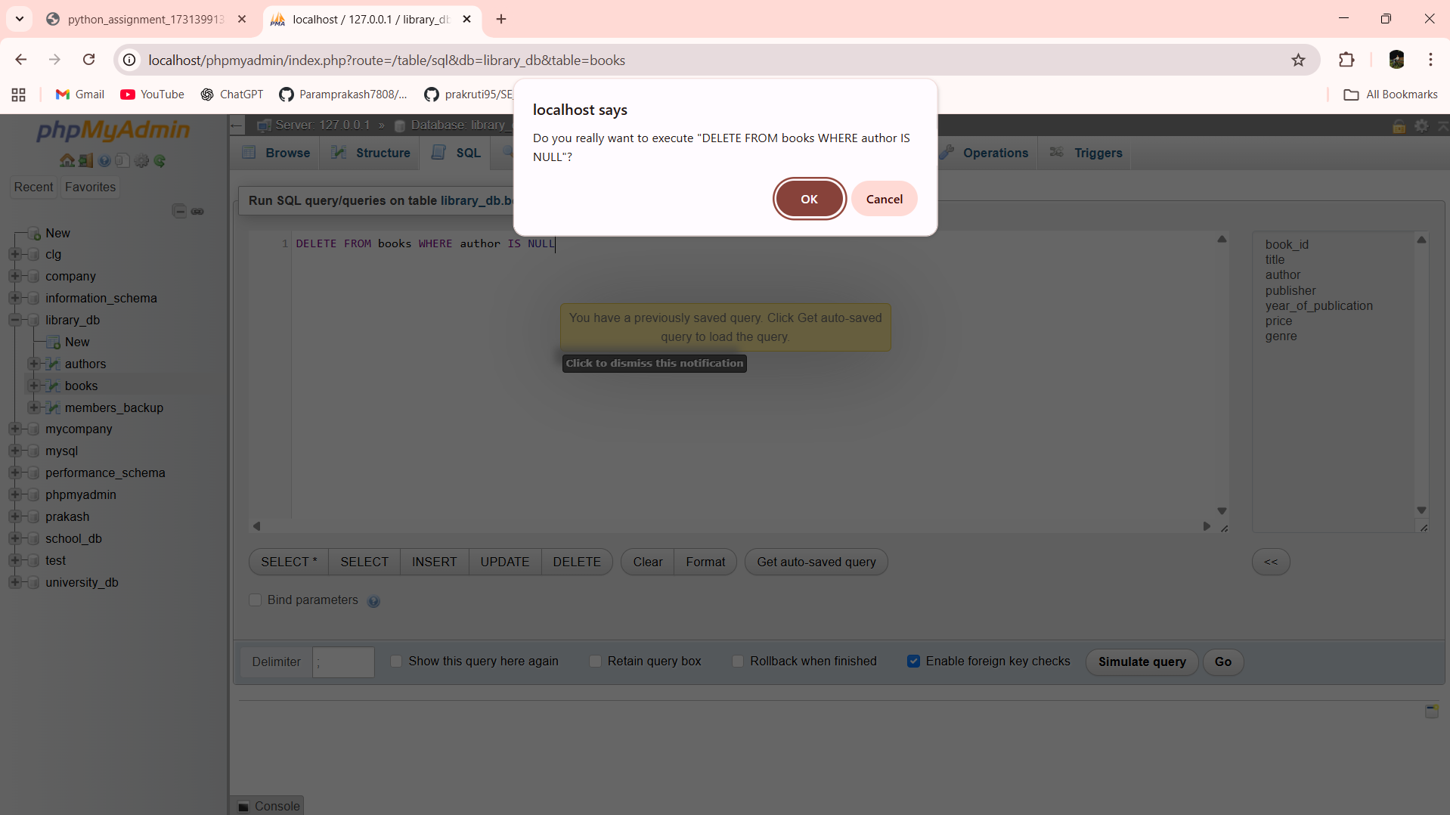

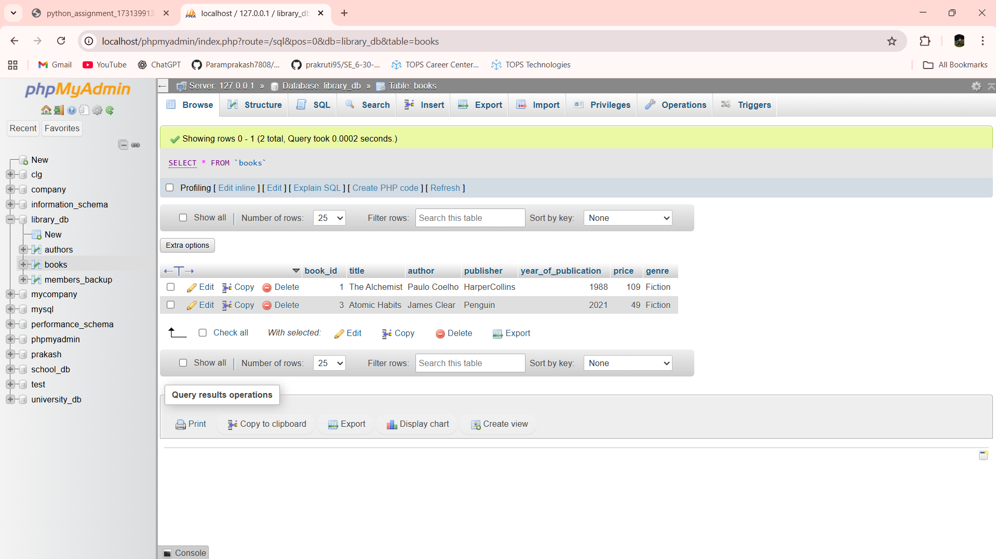

Lab 10.4: Write a query to retrieve all books with price between $50 and $100.

Ans:- SELECT * FROM books WHERE price BETWEEN 50 AND 100

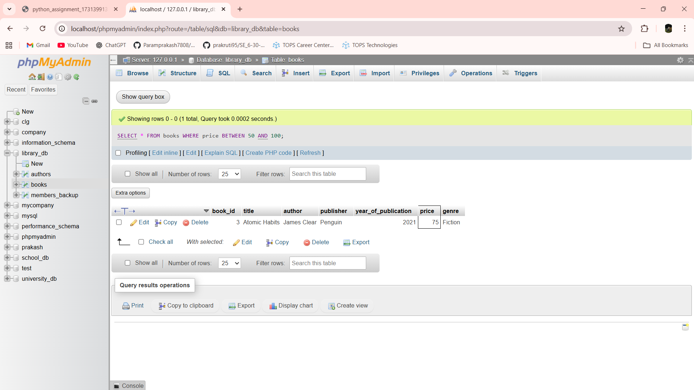

Lab 10.5: Retrieve the list of books sorted by author in ascending order and limit the results to the top 3 entries.

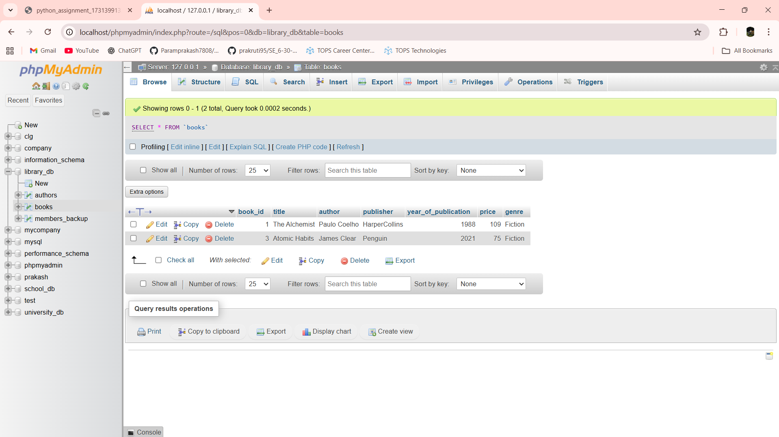

SELECT * FROM books ORDER BY author ASC LIMIT 1

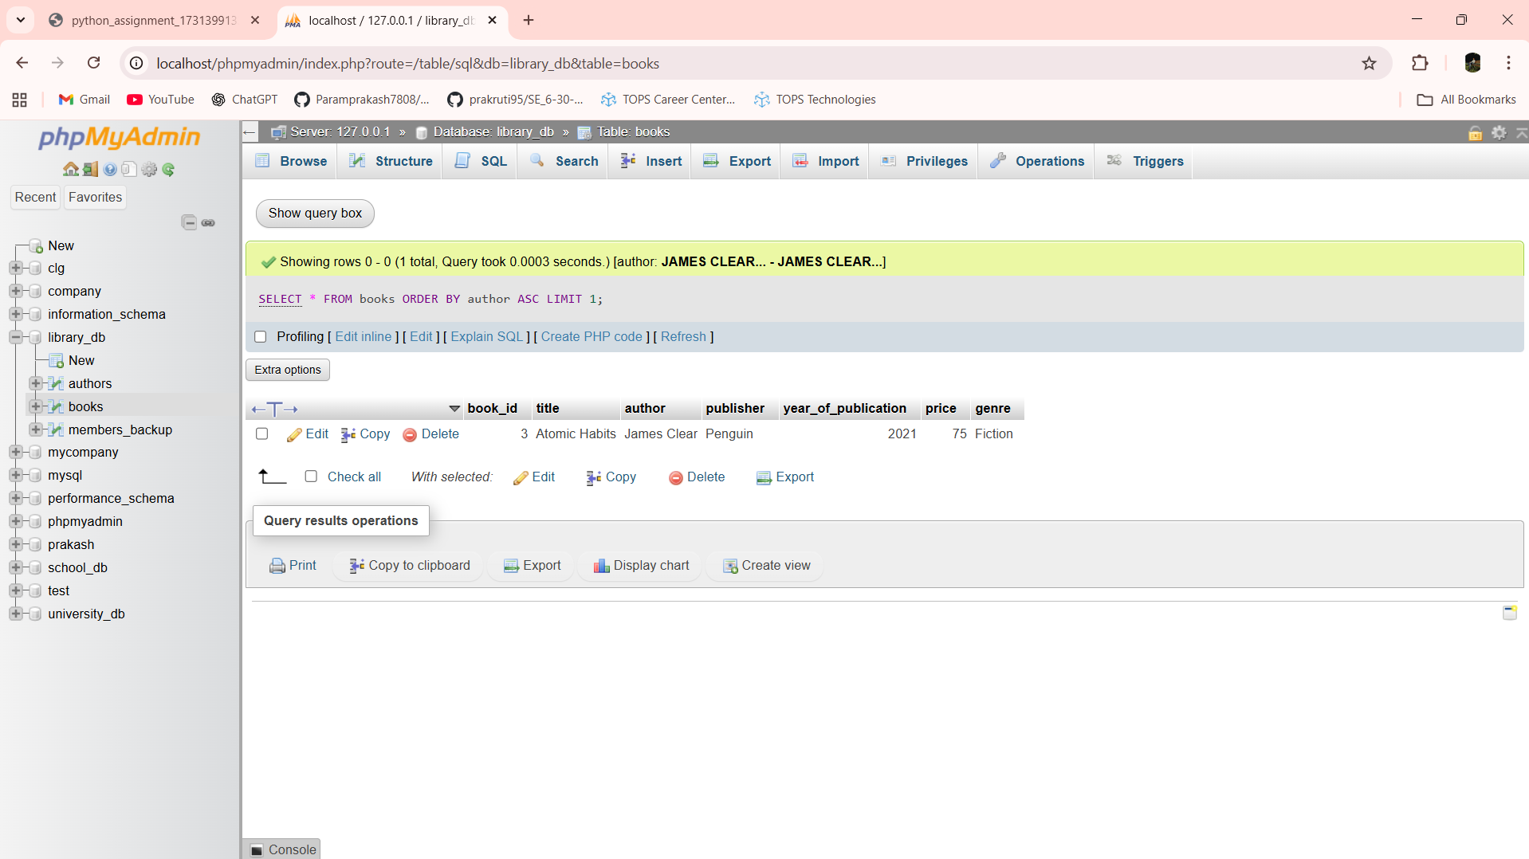

Lab 11.3: Grant SELECT permission to a user named librarian on the books table.

Ans:- GRANT SELECT ON library_db.books TO 'librarian'@'localhost';

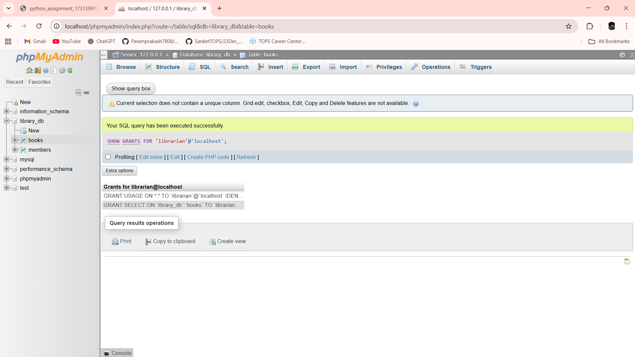

Lab 11.4: Grant INSERT and UPDATE permissions to the user admin on the members table.

Ans:- GRANT INSERT, UPDATE ON library_db.members TO 'admin'@'localhost';

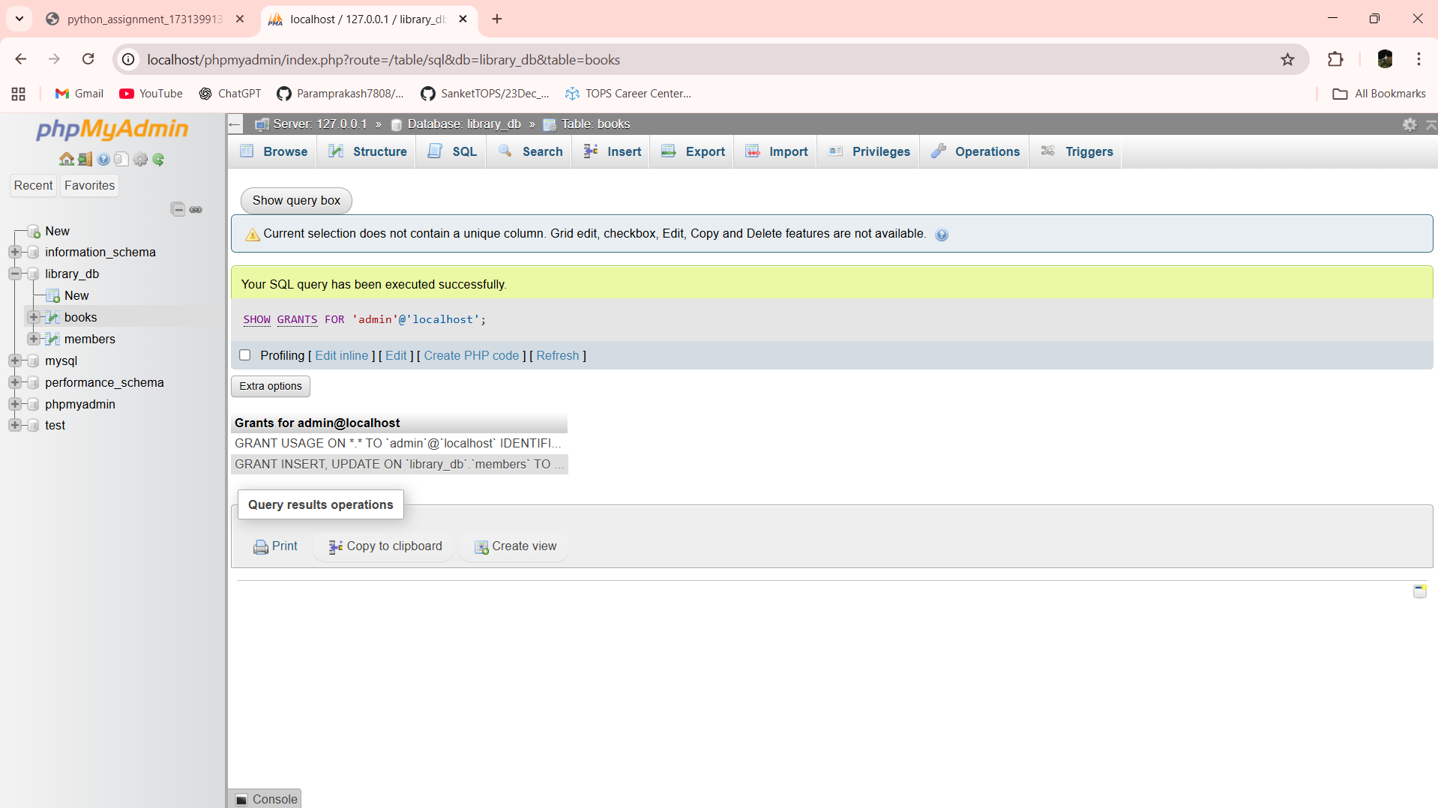

Lab 12.3: Revoke the INSERT privilege from the user librarian on the books table.

Ans:- REVOKE INSERT ON library_db.books FROM 'librarian'@'localhost';

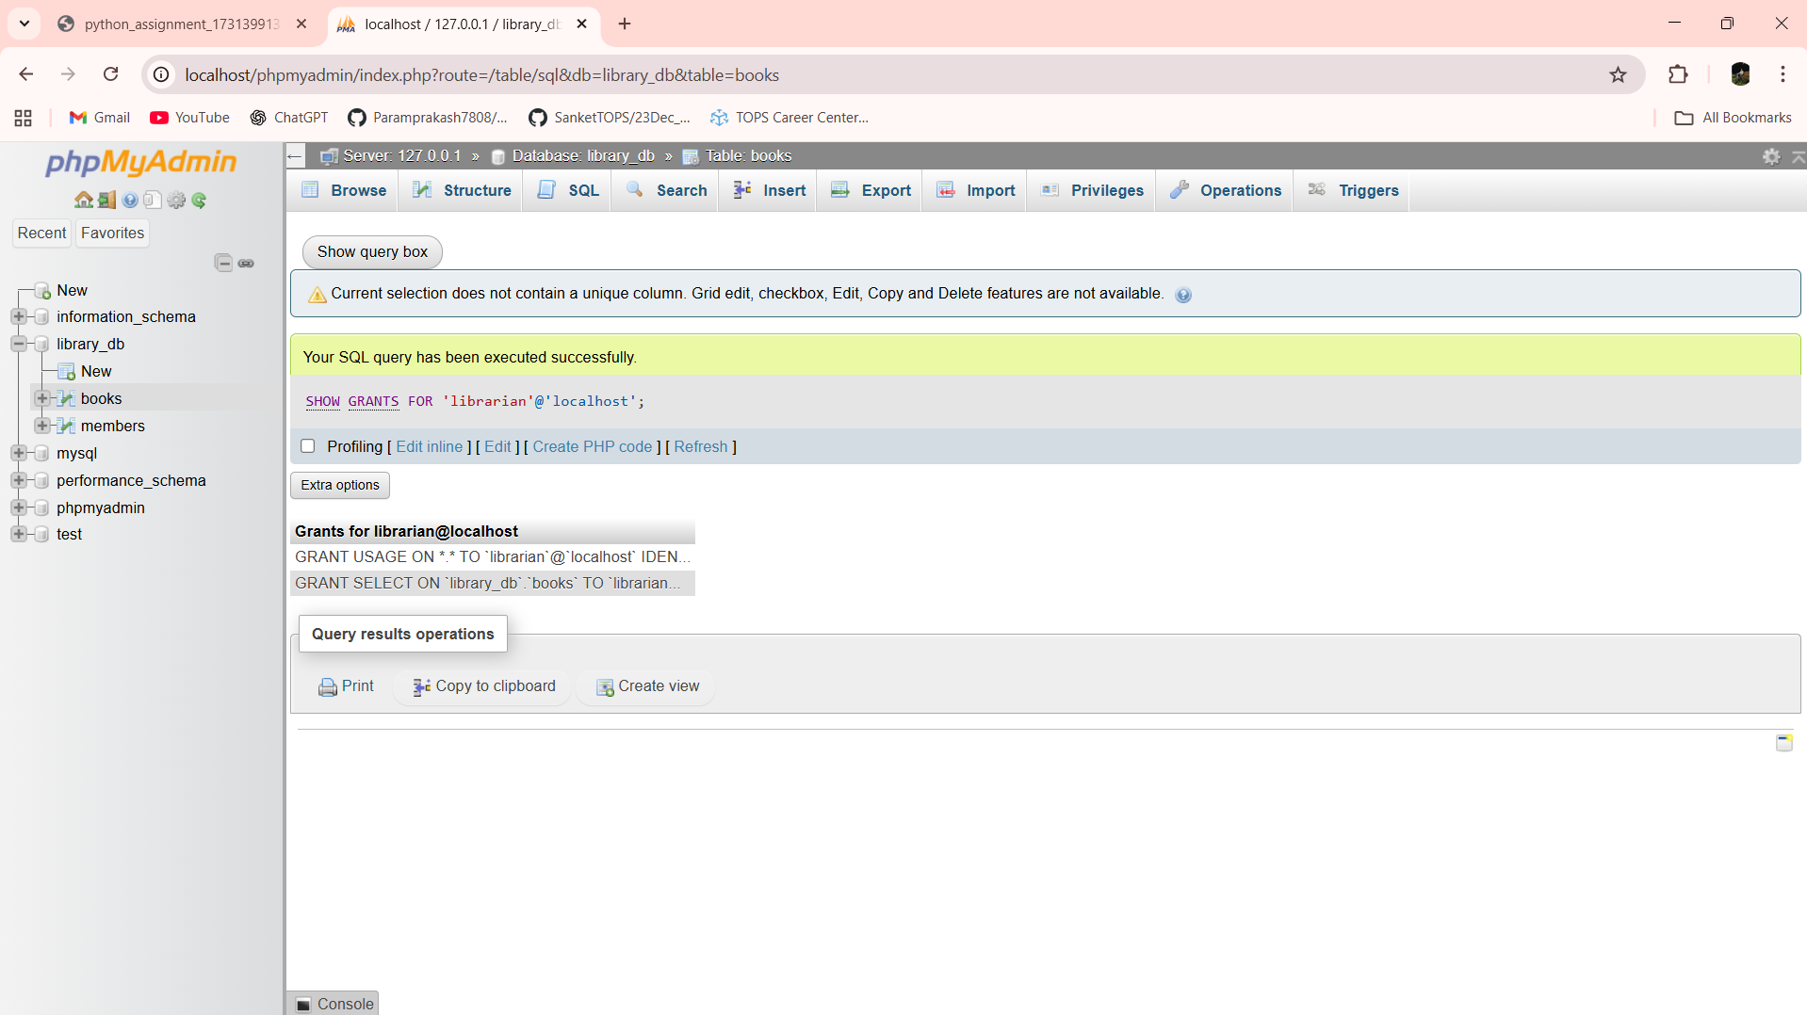

Lab 12.4: Revoke all permissions from user admin on the members table.

Ans:- REVOKE ALL PRIVILEGES ON library_db.members FROM 'admin'@'localhost';

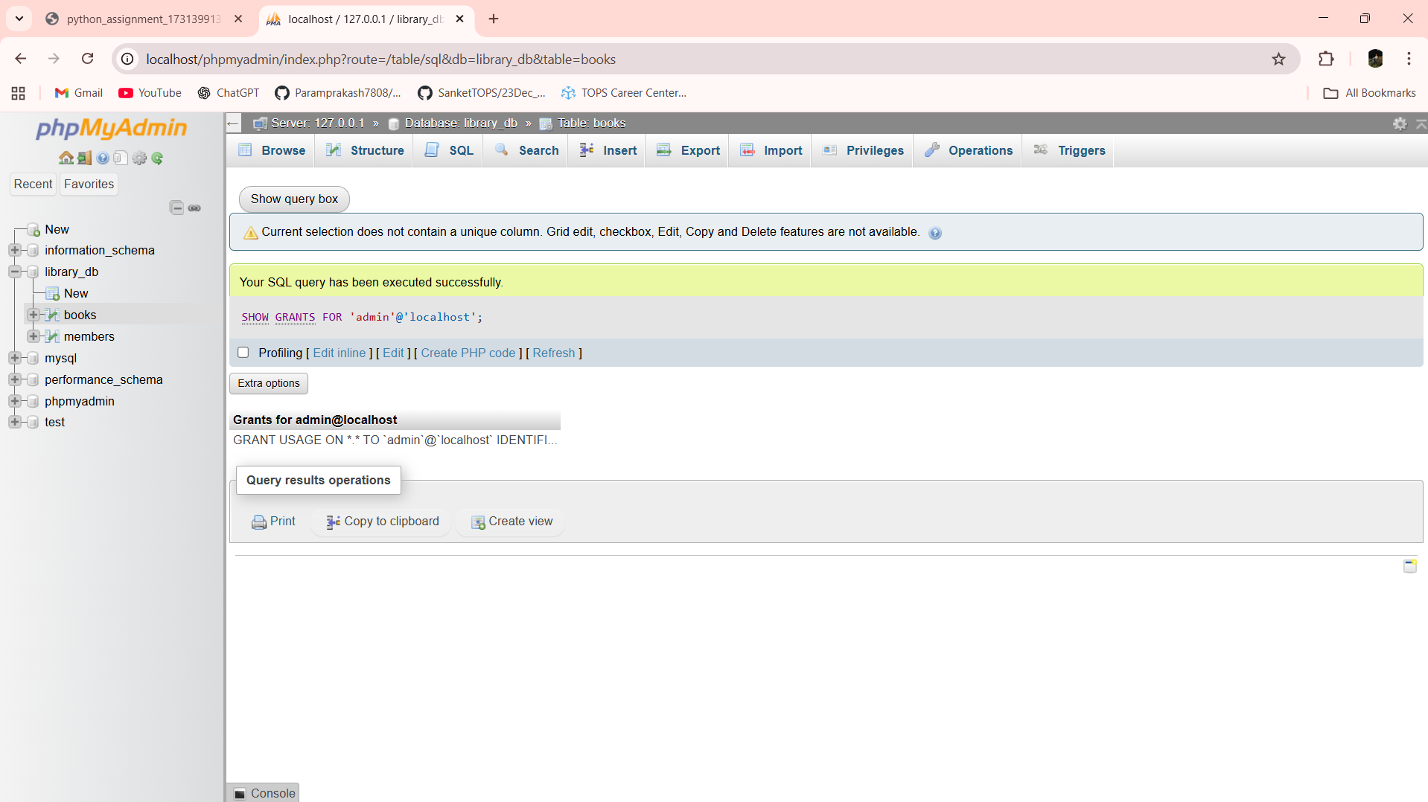

Lab 13.3: Use COMMIT after inserting multiple records into the books table, then make another insertion and perform a ROLLBACK.

Ans:- INSERT INTO books (title, author, price) VALUES

('Python Basics', 'Ravi Kumar', 280.00),

('Data Structures', 'Anil Mehta', 350.00);

COMMIT;

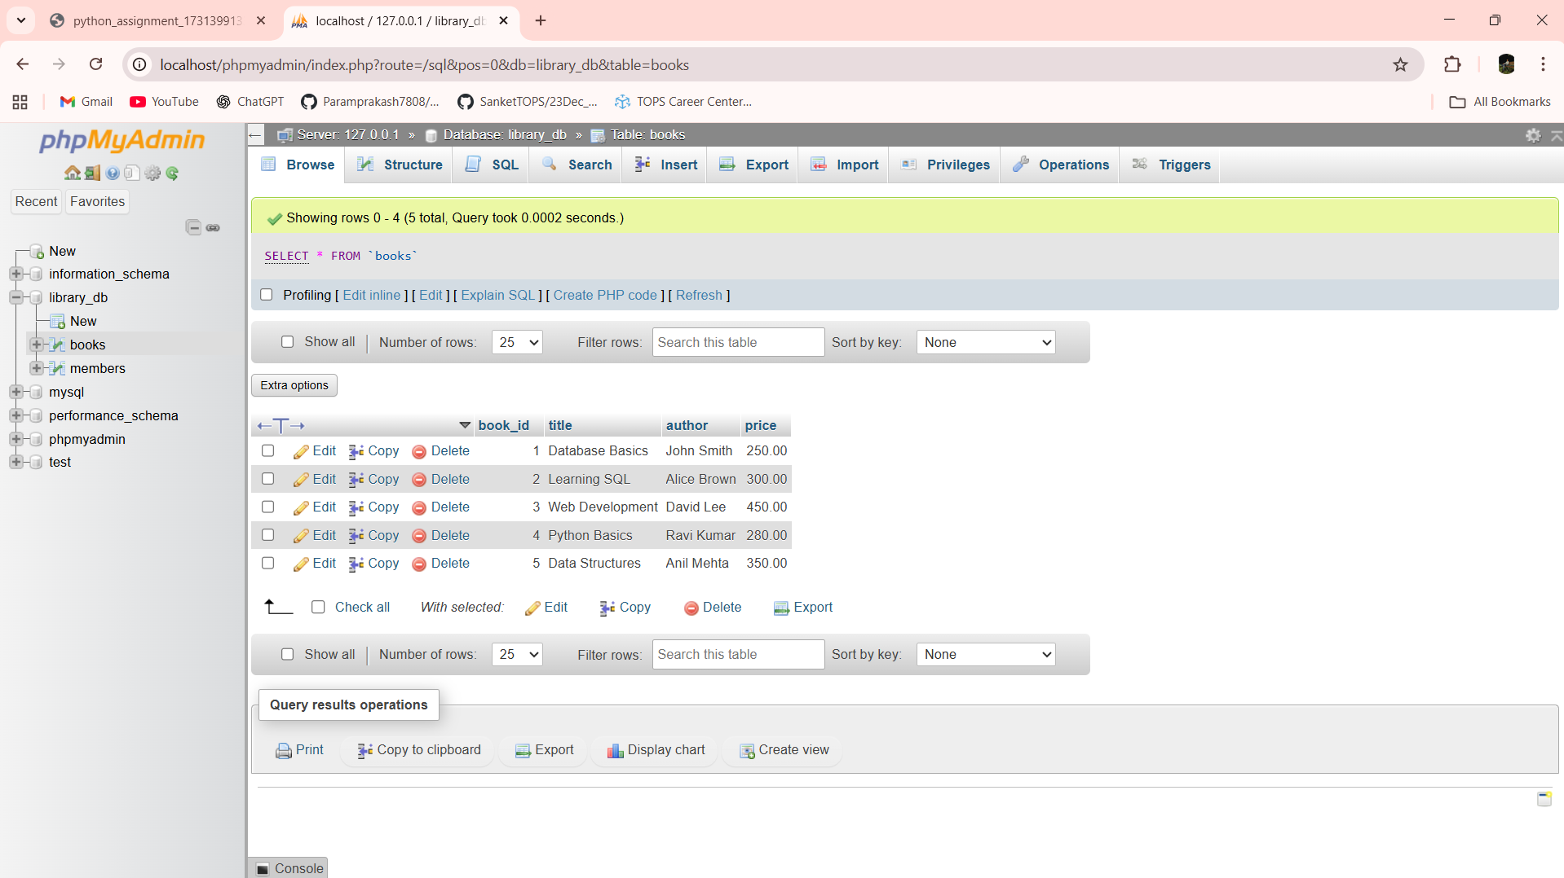

INSERT INTO books (title, author, price)

VALUES ('Machine Learning', 'Suresh Patel', 500.00);

ROLLBACK;

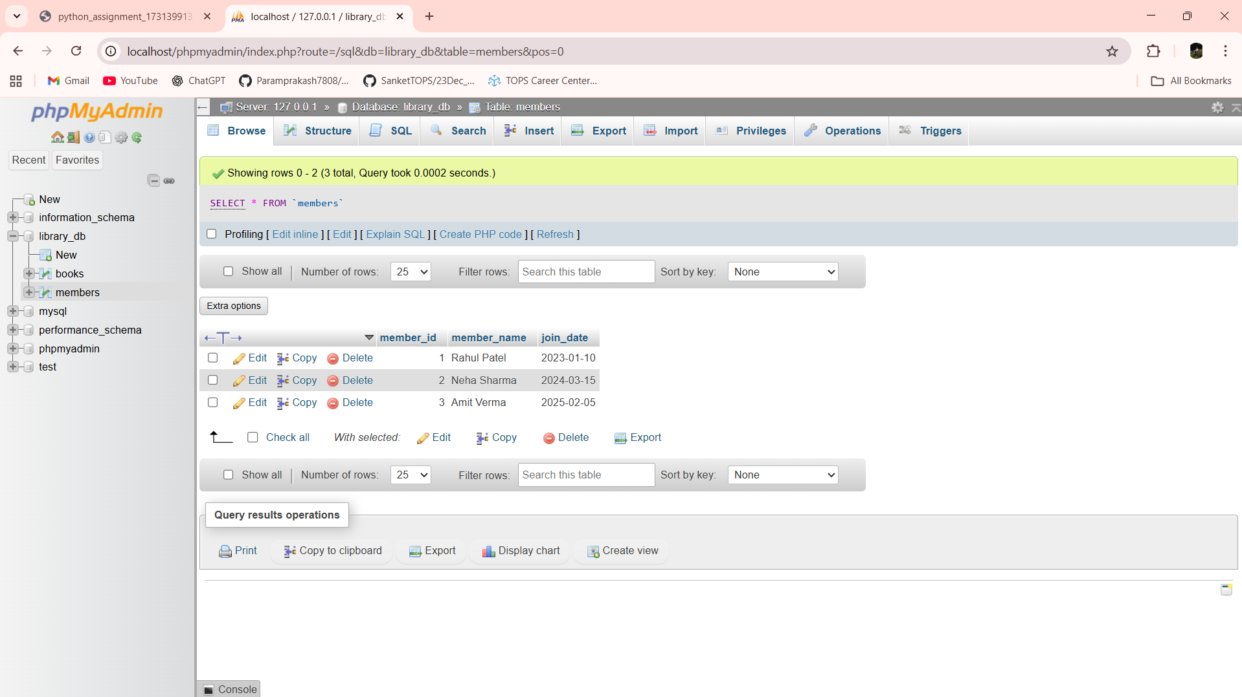

Lab 13.4: Set a SAVEPOINT before making updates to the members table, perform some updates, and then roll back to the SAVEPOINT.

Ans:- UPDATE members

SET member_name = 'Rahul Shah'

WHERE member_id = 1;

SAVEPOINT sp1;

UPDATE members

SET member_name = 'Neha Verma'

WHERE member_id = 2;

UPDATE members

SET member_name = 'Amit Joshi'

WHERE member_id = 3;

ROLLBACK TO SAVEPOINT sp1;

COMMIT;

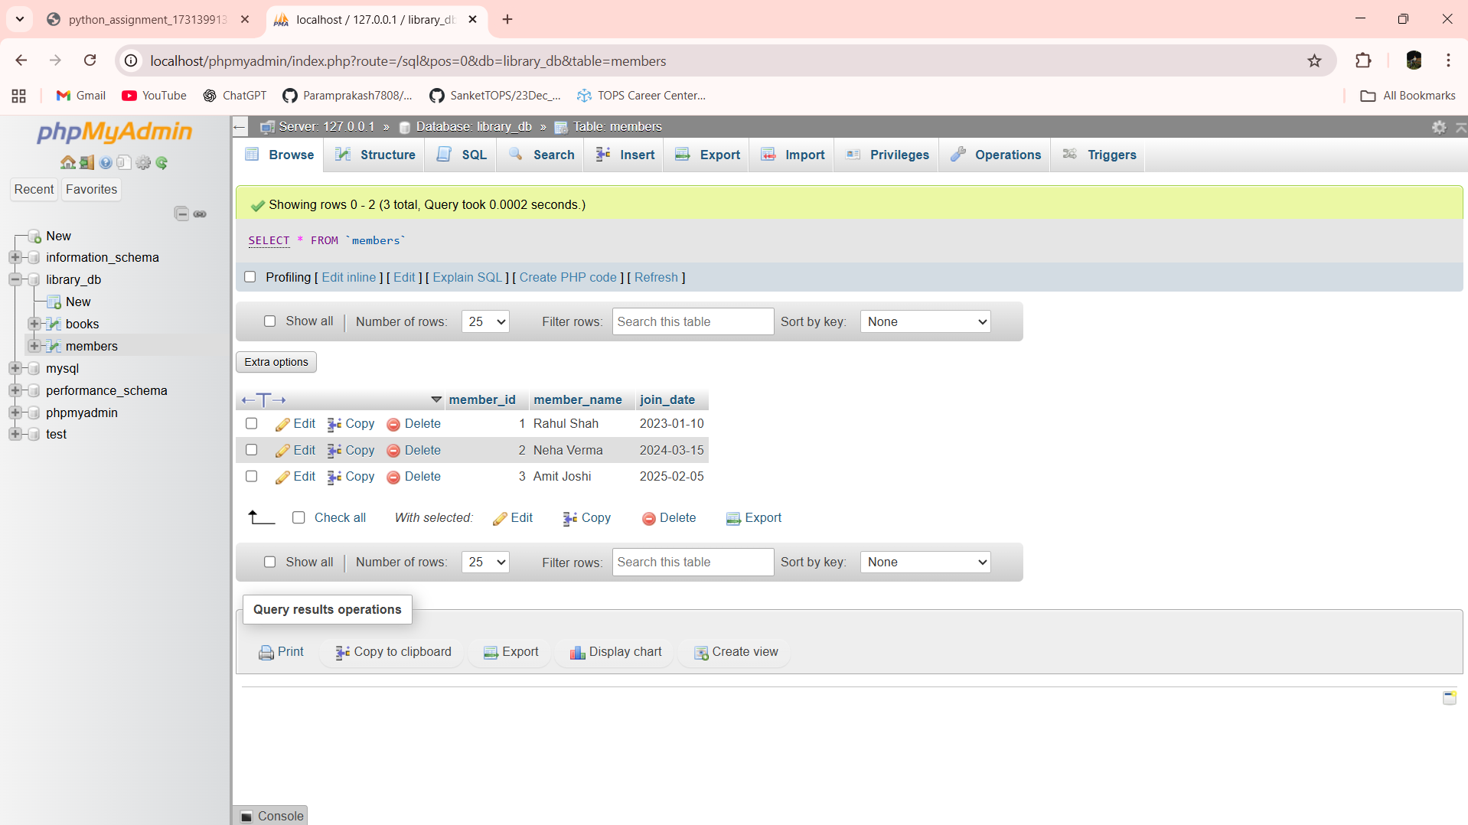

Lab 14.3: Perform an INNER JOIN between books and authors tables to display the title of books and their respective authors' names.

Ans:- SELECT b.title, a.author_name FROM books b INNER JOIN authors a ON b.author_id = a.author_id

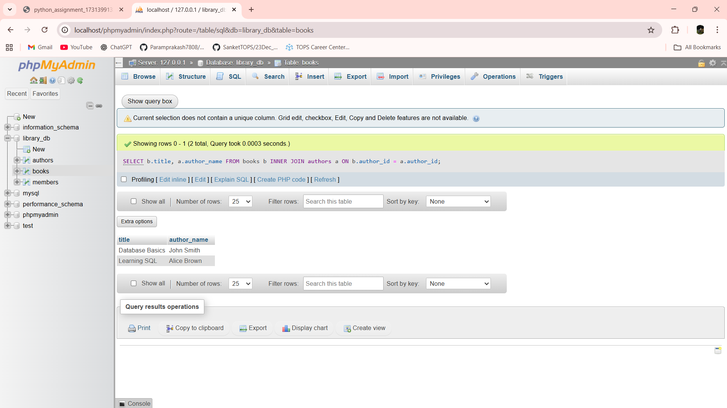

Lab 14.4: Use a FULL OUTER JOIN to retrieve all records from the books and authors tables, including those with no matching entries in the other table.

Ans:- SELECT b.title, a.author_name FROM books b LEFT JOIN authors a ON b.author_id = a.author_id

UNION

SELECT b.title, a.author_name FROM books b RIGHT JOIN authors a ON b.author_id = a.author_id

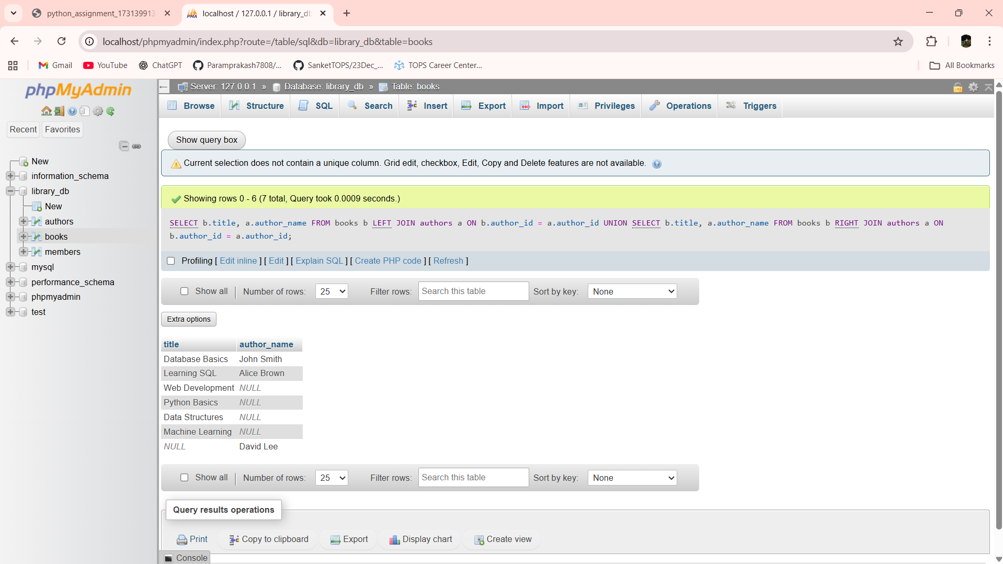

Lab 15.3: Group books by genre and display the total number of books in each genre.

Ans:- SELECT genre, COUNT(*) AS total_books FROM books GROUP BY genre

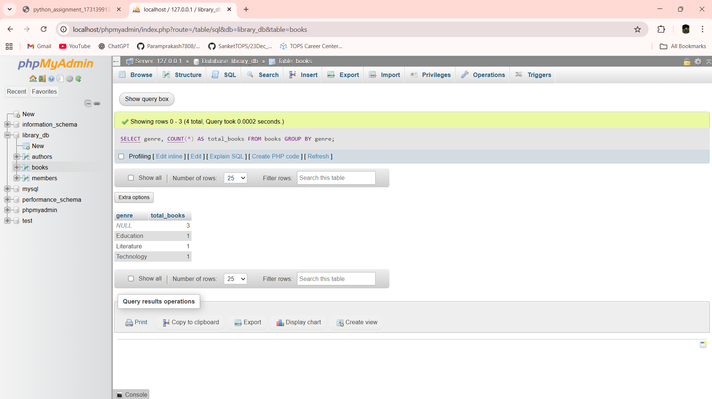

Lab 15.4: Group members by the year they joined and find the number of members who joined each year.

Ans:- SELECT YEAR(join_date) AS join_year, COUNT(*) AS total_members FROM members GROUP BY YEAR(join_date)

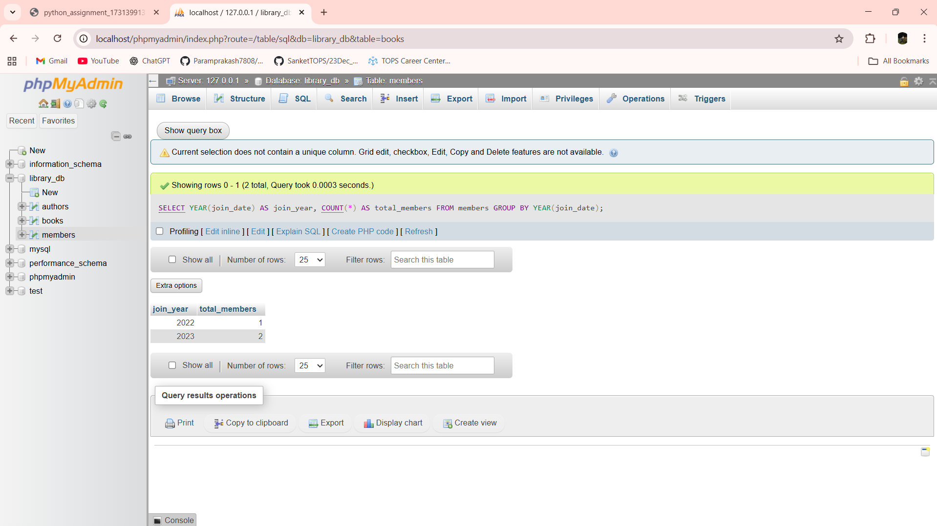

Lab 16.3: Write a stored procedure to retrieve all books by a particular author.

Ans:- DELIMITER $$

CREATE PROCEDURE get_books_by_author(IN p_author VARCHAR(100))

BEGIN

SELECT book_id, title, price

FROM books

WHERE author = p_author;

END$$

DELIMITER ;

CALL get_books_by_author('John Smith');

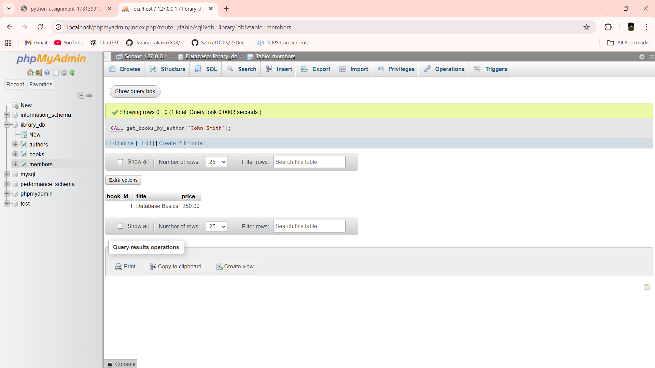

Lab 16.4: Write a stored procedure that takes book_id as an argument and returns the price of the book.

Ans:- DELIMITER $$

CREATE PROCEDURE get_book_price(IN p_book_id INT)

BEGIN

SELECT price

FROM books

WHERE book_id = p_book_id;

END$$

DELIMITER ;

CALL get_book_price(1);

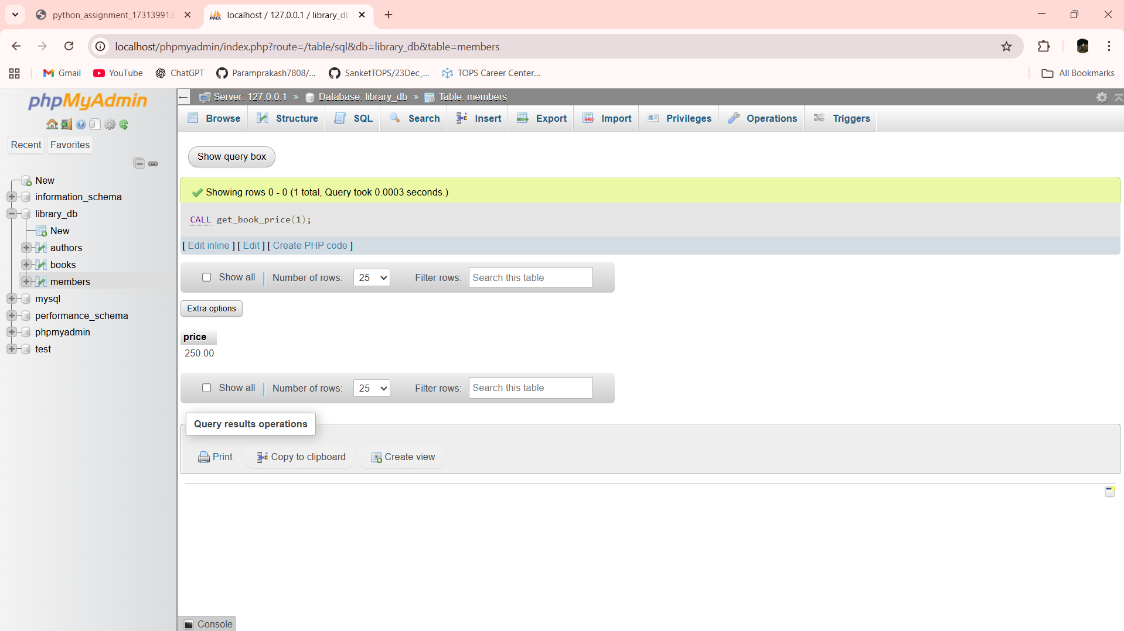

Lab 17.3: Create a view to show only the title, author, and price of books from the books table.

Ans:- CREATE VIEW view_books_basic AS SELECT title, author, price FROM books

SELECT * FROM view_books_basic;

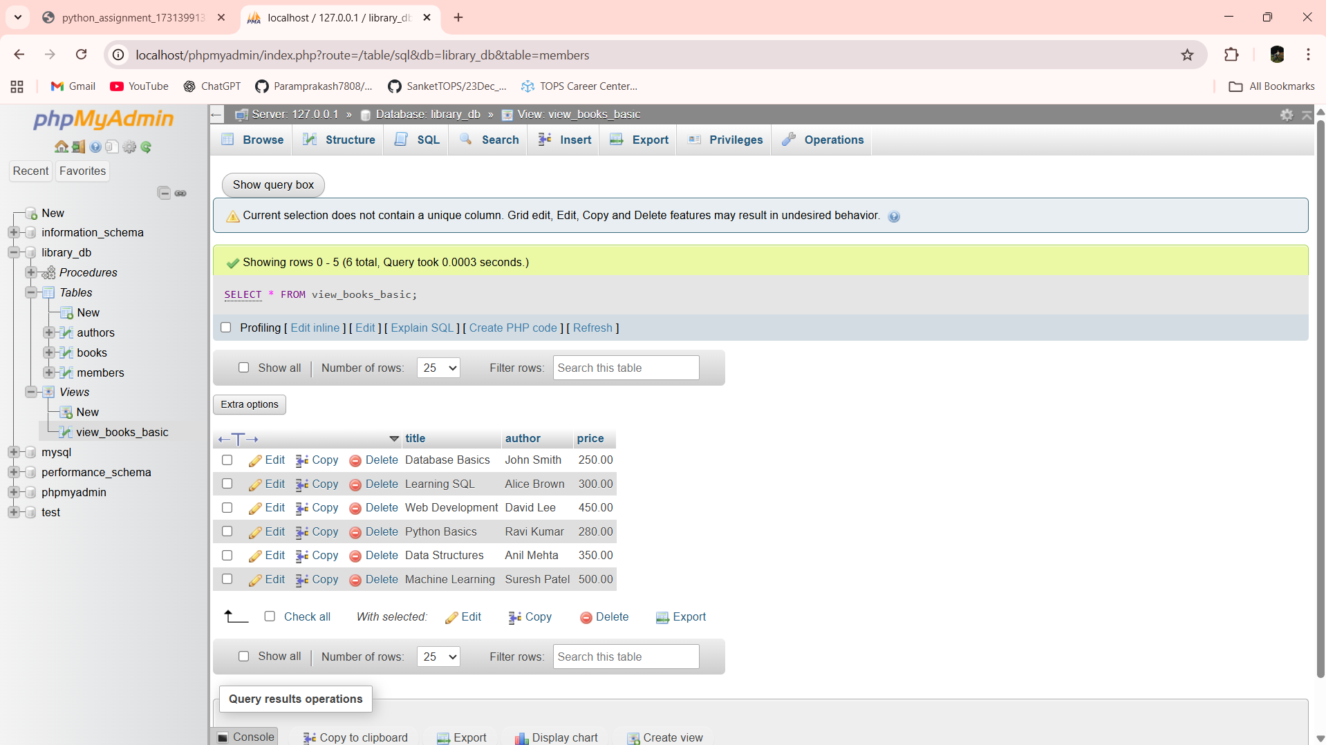

Lab 17.4: Create a view to display members who joined before 2020.

Ans:- CREATE VIEW view_members_before_2020 AS SELECT member_id, member_name, join_date FROM members WHERE join_date < '2020-01-01'

SELECT * FROM view_members_before_2020;

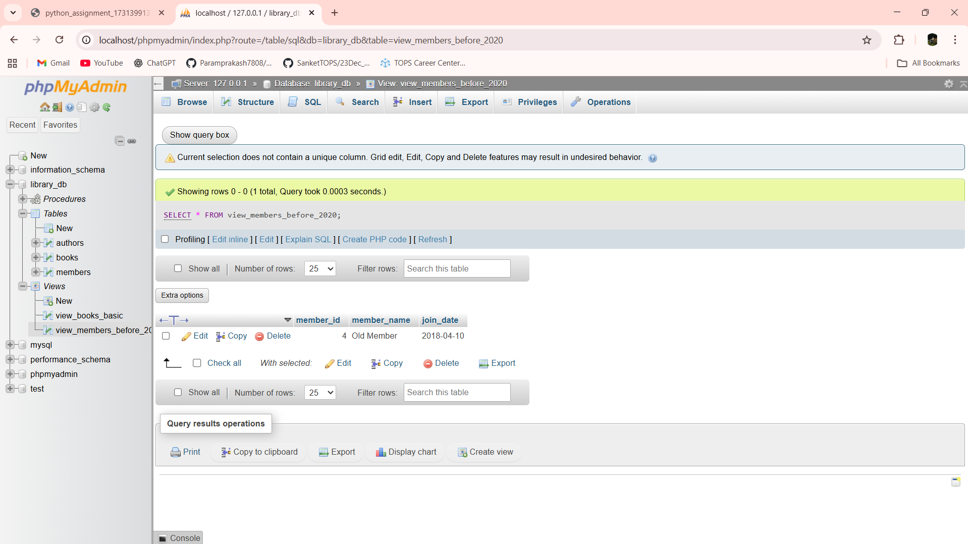

Lab 18.3: Create a trigger to automatically update the last_modified timestamp of the books table whenever a record is updated.

Ans:- DELIMITER $$

CREATE TRIGGER trg_books_last_modified

BEFORE UPDATE ON books

FOR EACH ROW

BEGIN

SET NEW.last_modified = CURRENT_TIMESTAMP;

END$$

DELIMITER ;

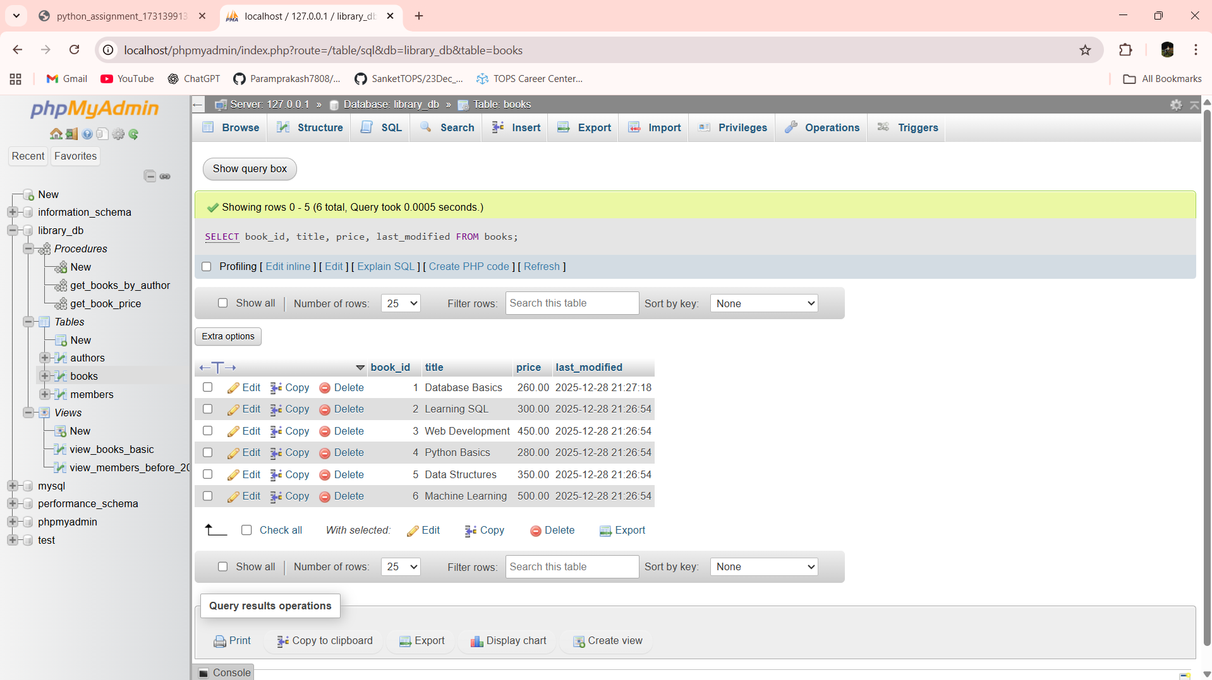

Lab 18.4: Create a trigger that inserts a log entry into a log_changes table whenever a DELETE operation is performed on the books table.

Ans:- DELIMITER $$

CREATE TRIGGER trg_books_delete_log

AFTER DELETE ON books

FOR EACH ROW

BEGIN

INSERT INTO log_changes (book_id, action_type)

VALUES (OLD.book_id, 'DELETE');

END$$

DELIMITER ;

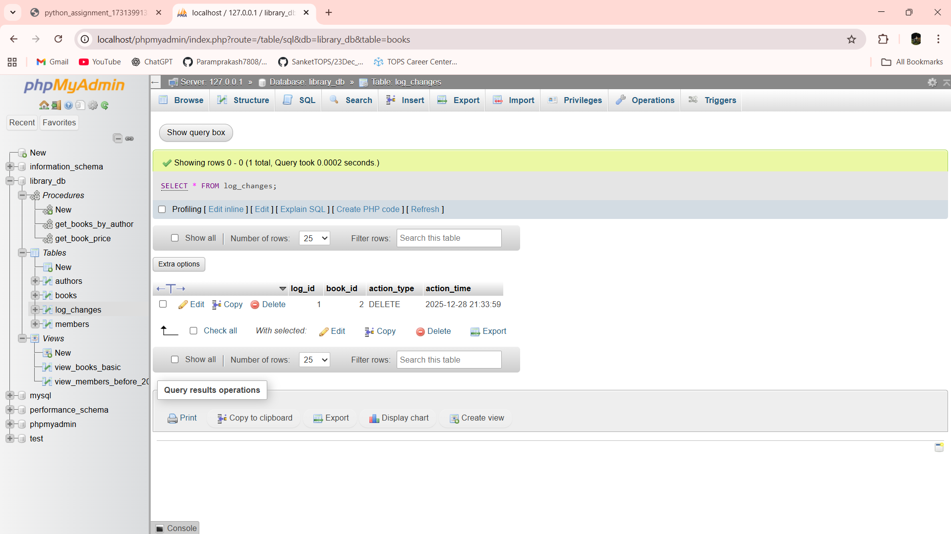

Lab 19.3: Write a PL/SQL block to insert a new book into the books table and display a confirmation message.

Ans:- DELIMITER $$

CREATE PROCEDURE insert_book()

BEGIN

INSERT INTO books (title, author, price)

VALUES ('Operating Systems', 'Andrew Tanenbaum', 550.00);

SELECT 'Book inserted successfully' AS message;

END$$

DELIMITER ;

CALL insert_book();

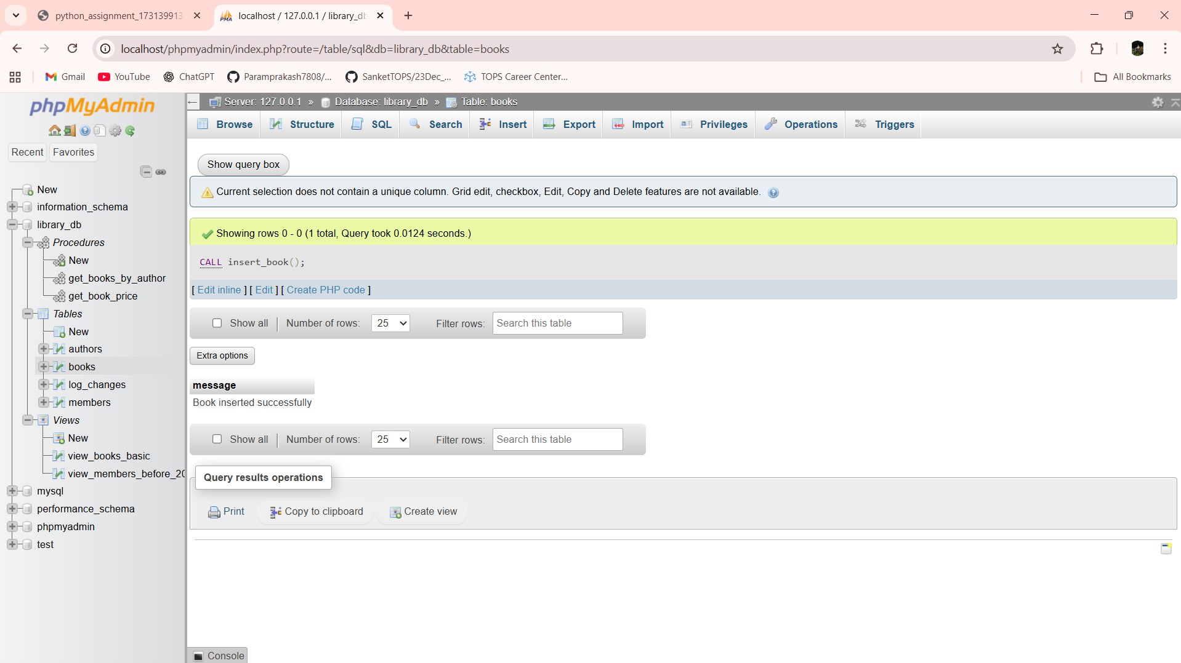

SELECT * FROM books;

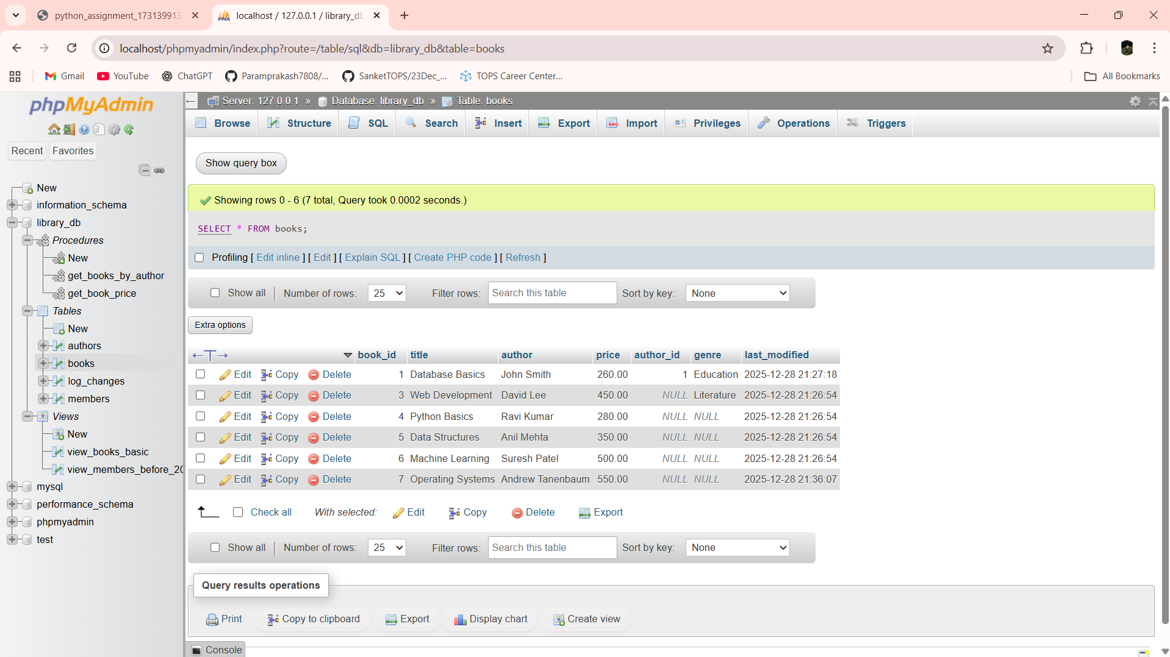

Lab 19.4: Write a PL/SQL block to display the total number of books in the books table.

Ans:- DELIMITER $$

CREATE PROCEDURE total_books()

BEGIN

DECLARE total INT;

SELECT COUNT(*) INTO total FROM books;

SELECT total AS total_number_of_books;

END$$

DELIMITER ;

CALL total_books();

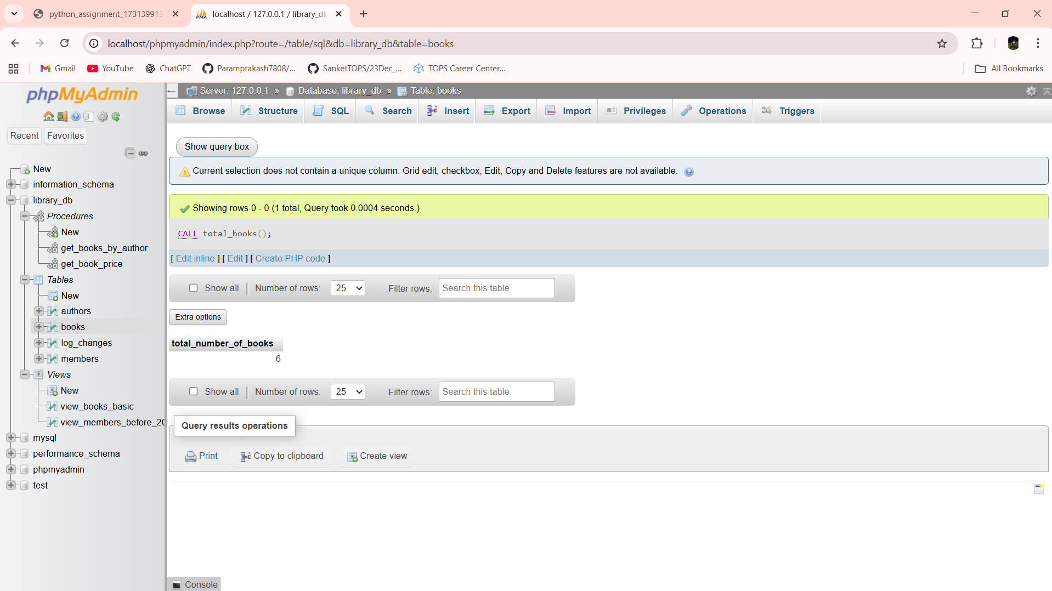

Lab 20.3: Write a PL/SQL block to declare variables for book_id and price, assign values, and display the results.

Ans:- DELIMITER $$

CREATE PROCEDURE show_book_values()

BEGIN

DECLARE v_book_id INT;

DECLARE v_price DECIMAL(6,2);

SET v_book_id = 101;

SET v_price = 450.75;

SELECT v_book_id AS book_id, v_price AS price;

END$$

DELIMITER ;

CALL show_book_values();

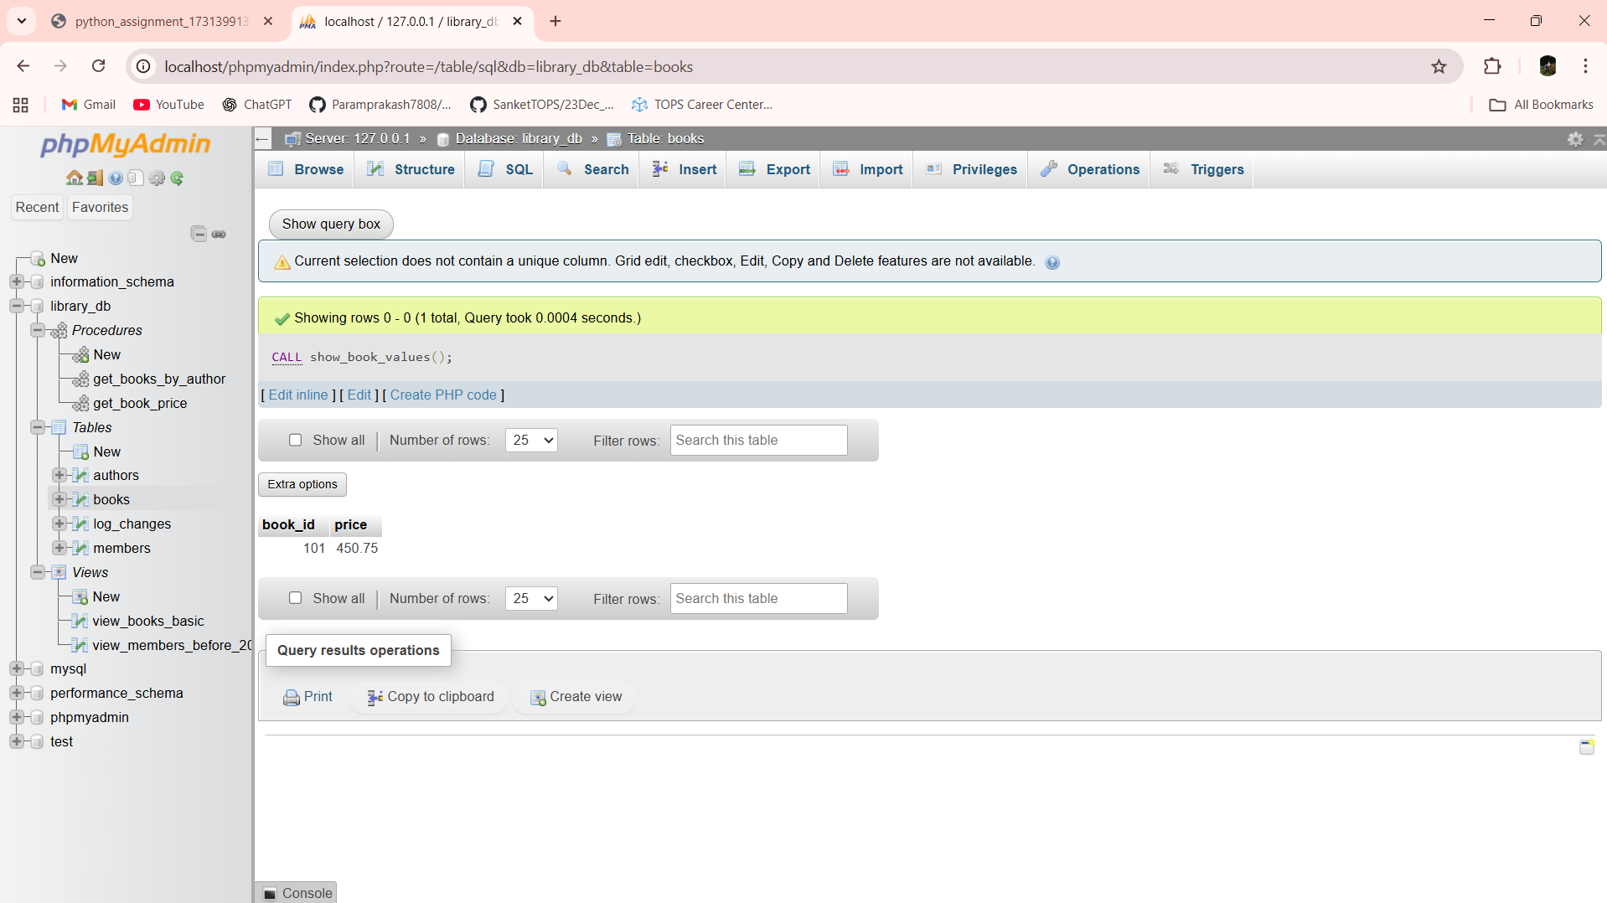

Lab 20.4: Write a PL/SQL block using constants and perform arithmetic operations on book prices.

Ans:- DELIMITER $$

CREATE PROCEDURE book_price_calculation()

BEGIN

DECLARE base_price DECIMAL(6,2) DEFAULT 500.00;

DECLARE discount_rate DECIMAL(4,2) DEFAULT 0.10;

DECLARE final_price DECIMAL(6,2);

SET final_price = base_price - (base_price * discount_rate);

SELECT base_price AS original_price,

final_price AS discounted_price;

END$$

DELIMITER ;

CALL book_price_calculation();

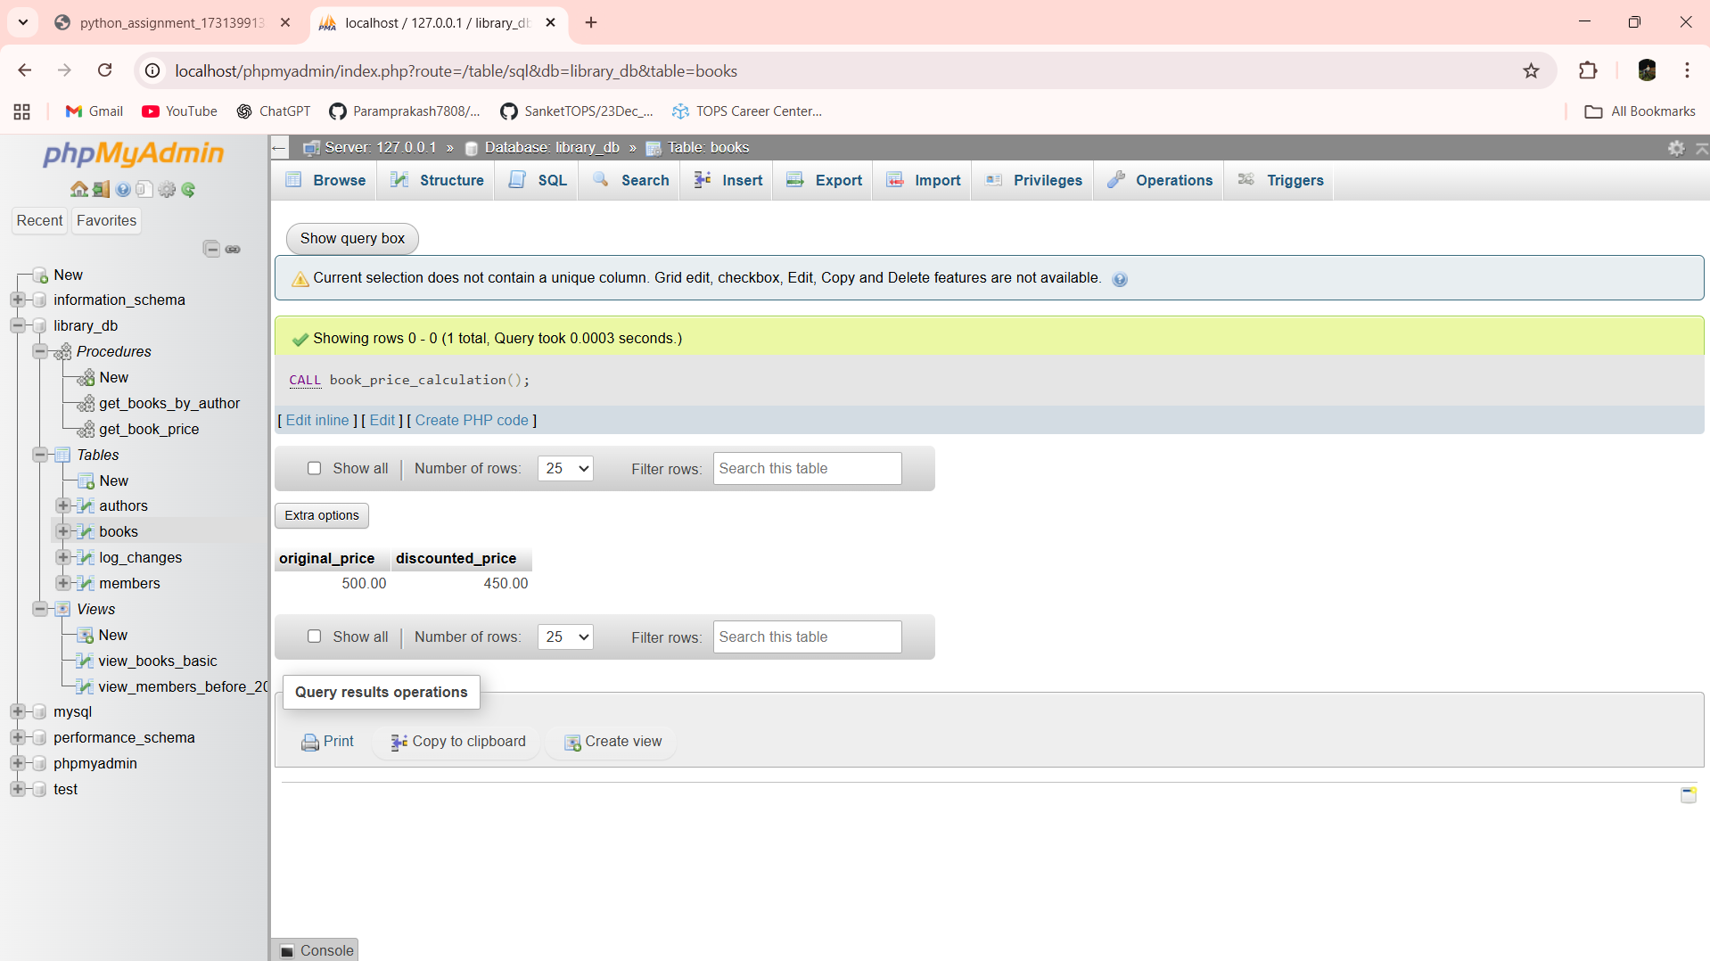

Lab 21.3: Write a PL/SQL block using IF-THEN-ELSE to check if a book's price is above $100 and print a message accordingly.

Ans:- DELIMITER $$

CREATE PROCEDURE check_book_price()

BEGIN

DECLARE v_price DECIMAL(6,2);

SELECT price INTO v_price

FROM books

WHERE book_id = 1;

IF v_price > 100 THEN

SELECT 'Book price is above 100' AS message;

ELSE

SELECT 'Book price is 100 or below' AS message;

END IF;

END$$

DELIMITER ;

CALL check_book_price();

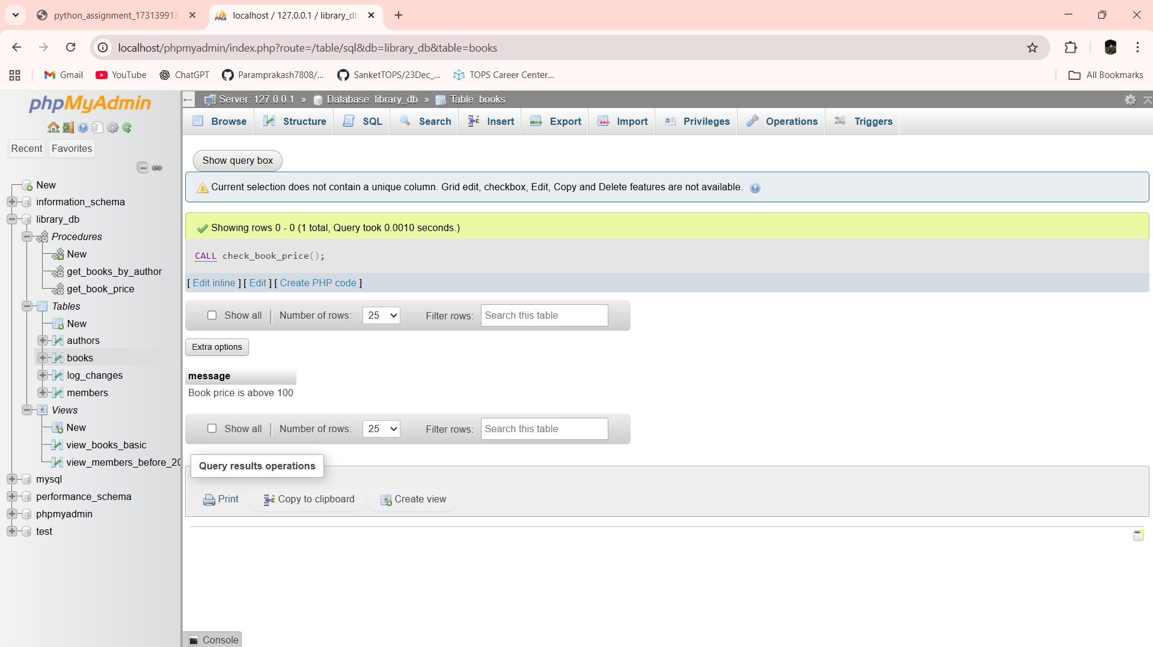

Lab 21.4: Use a FOR LOOP in PL/SQL to display the details of all books one by one.

Ans:- DELIMITER $$

CREATE PROCEDURE display_all_books()

BEGIN

DECLARE done INT DEFAULT 0;

DECLARE v_id INT;

DECLARE v_title VARCHAR(100);

DECLARE v_price DECIMAL(6,2);

DECLARE book_cursor CURSOR FOR

SELECT book_id, title, price FROM books;

DECLARE CONTINUE HANDLER FOR NOT FOUND SET done = 1;

OPEN book_cursor;

read_loop: LOOP

FETCH book_cursor INTO v_id, v_title, v_price;

IF done = 1 THEN

LEAVE read_loop;

END IF;

SELECT v_id AS book_id, v_title AS title, v_price AS price;

END LOOP;

CLOSE book_cursor;

END$$

DELIMITER ;

CALL display_all_books();

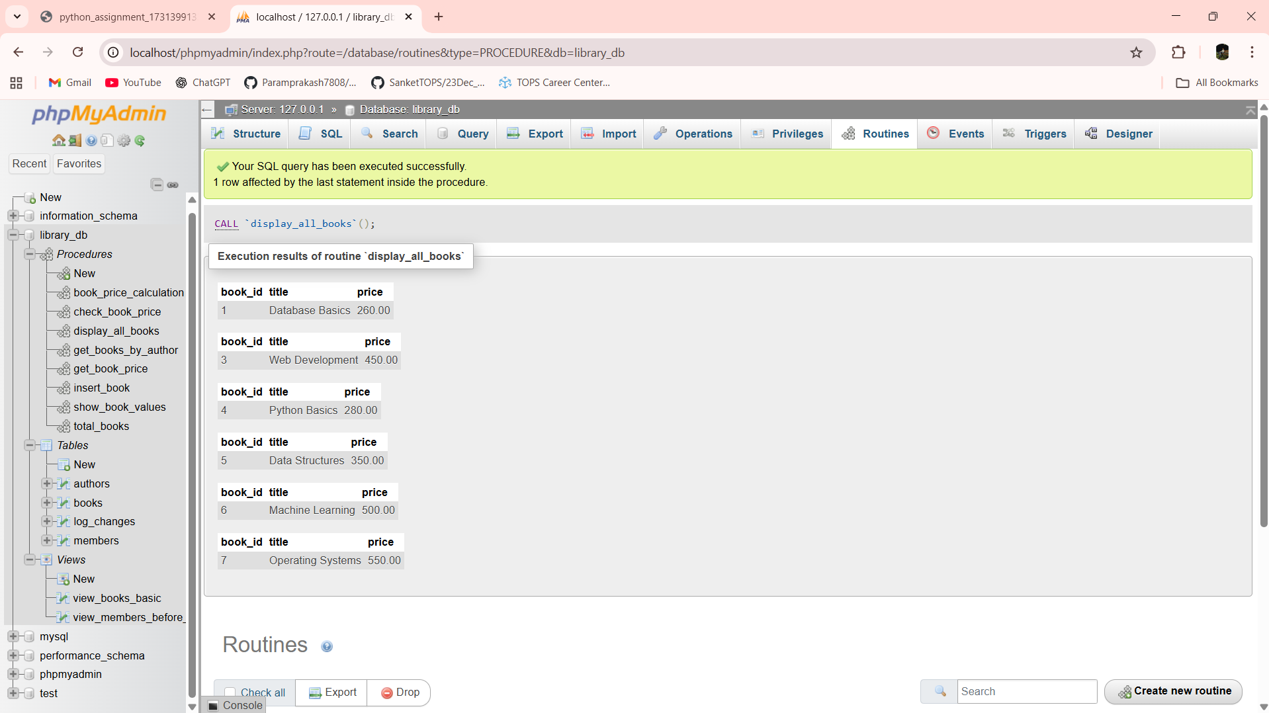

Lab 22.3: Write a PL/SQL block using an explicit cursor to fetch and display all records from the members table.

Ans:- DELIMITER $$

CREATE PROCEDURE show_all_members()

BEGIN

DECLARE done INT DEFAULT 0;

DECLARE v_id INT;

DECLARE v_name VARCHAR(100);

DECLARE v_join_date DATE;

DECLARE member_cursor CURSOR FOR

SELECT member_id, member_name, join_date FROM members;

DECLARE CONTINUE HANDLER FOR NOT FOUND SET done = 1;

OPEN member_cursor;

read_loop: LOOP

FETCH member_cursor INTO v_id, v_name, v_join_date;

IF done = 1 THEN

LEAVE read_loop;

END IF;

SELECT v_id AS member_id,

v_name AS member_name,

v_join_date AS join_date;

END LOOP;

CLOSE member_cursor;

END$$

DELIMITER ;

CALL show_all_members();

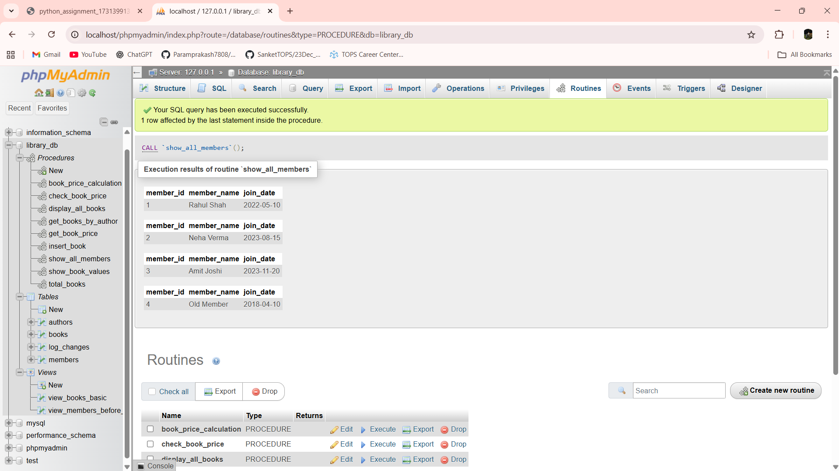

Lab 22.4: Create a cursor to retrieve books by a particular author and display their titles.

Ans:- DELIMITER $$

CREATE PROCEDURE books_by_author(IN p_author VARCHAR(100))

BEGIN

DECLARE done INT DEFAULT 0;

DECLARE v_title VARCHAR(100);

DECLARE book_cursor CURSOR FOR

SELECT title FROM books WHERE author = p_author;

DECLARE CONTINUE HANDLER FOR NOT FOUND SET done = 1;

OPEN book_cursor;

read_loop: LOOP

FETCH book_cursor INTO v_title;

IF done = 1 THEN

LEAVE read_loop;

END IF;

SELECT v_title AS book_title;

END LOOP;

CLOSE book_cursor;

END$$

DELIMITER ;

CALL books_by_author('John Smith');

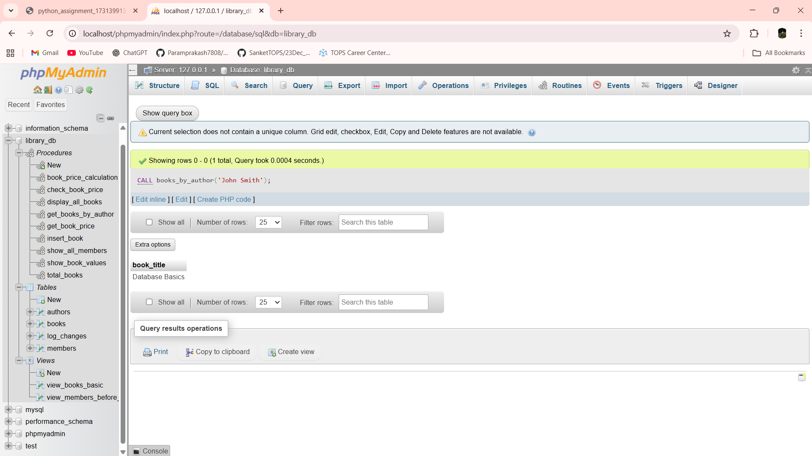

Lab 23.3: Perform a transaction that includes inserting a new member, setting a SAVEPOINT, and rolling back to the savepoint after making updates.

Ans:- START TRANSACTION;

INSERT INTO members (member_name, join_date)

VALUES ('Temporary Member', '2024-05-01');

SAVEPOINT sp_member;

UPDATE members

SET member_name = 'Updated Member'

WHERE member_name = 'Temporary Member';

ROLLBACK TO SAVEPOINT sp_member;

COMMIT;

SELECT * FROM members;

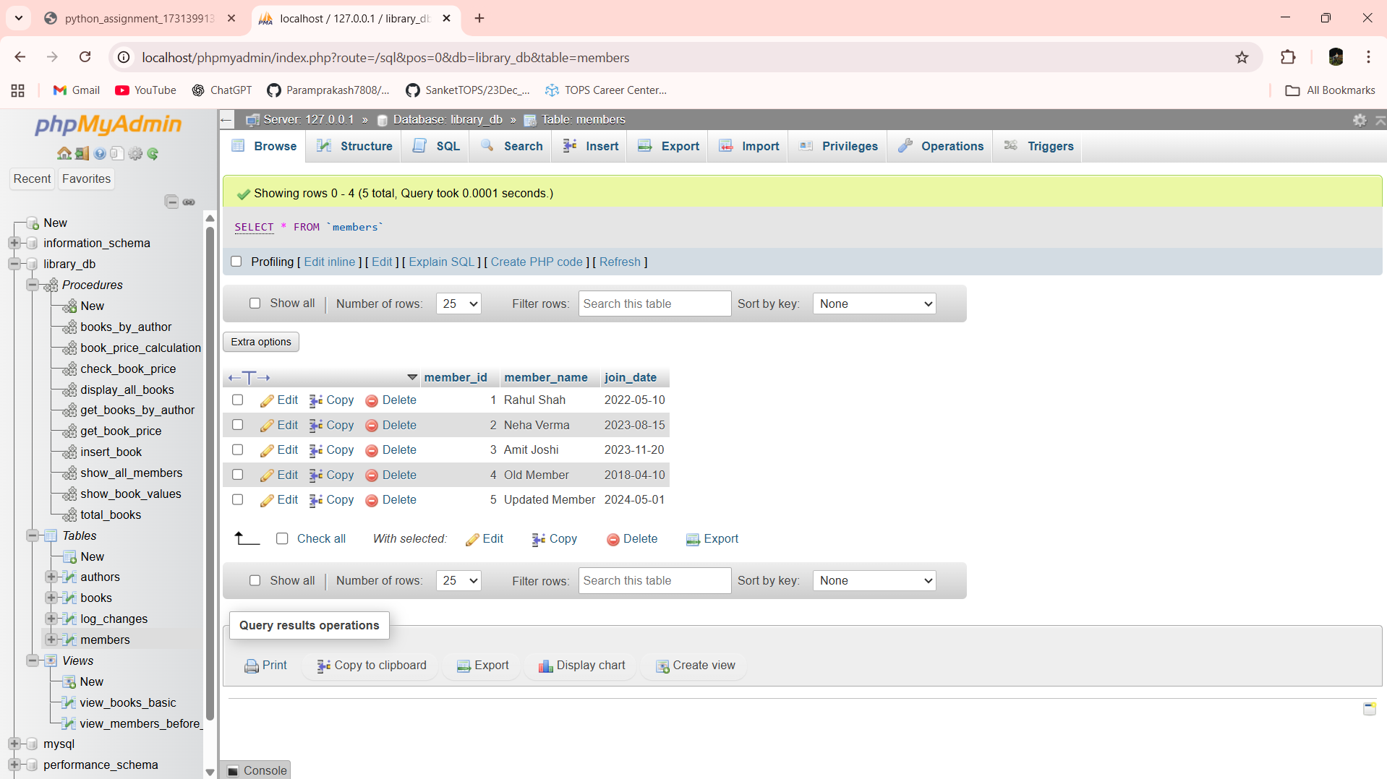

Lab 23.4: Use COMMIT after successfully inserting multiple books into the books table, then use ROLLBACK to undo a set of changes made after a savepoint.

Ans:- START TRANSACTION;

INSERT INTO books (title, author, price)

VALUES

('Cloud Computing', 'Raj Mehta', 400),

('Data Mining', 'Anita Rao', 450);

COMMIT;

START TRANSACTION;

SAVEPOINT sp_books;

UPDATE books SET price = price + 50 WHERE title = 'Cloud Computing';

DELETE FROM books WHERE title = 'Data Mining';

ROLLBACK TO SAVEPOINT sp_books;

COMMIT;

SELECT * FROM books;

